Urban Informatics: An Open-Source Computational Pipeline for Longitudinal Urban Safety Monitoring Integrating Climate Data, Police Records, and Social Media Sentiment.
Varuni Jayasooriya, Ryan Ocampo
School of Environment and Sustainability, University of Saskatchewan, Saskatoon, Canada

Highlights

- An open-source, reproducible Python pipeline (Urban Informatics) integrates climate, crime, and social media data for longitudinal urban safety monitoring across four Canadian Prairie cities.
- An era-stratification framework demonstrates that Reddit-derived sentiment is a reliable public perception proxy only under conditions of platform maturity and social stability — partially collapsing during the COVID-19 pandemic.
- Edmonton's annual violent crime correlates with mean relative humidity (r = −0.744) and cooling degree days (r = +0.707), but neither association survives removal of shared 2010–2024 time trends (detrended r = +0.27 and +0.11, both p > 0.3).
- A built-in trend-robustness test shows that Edmonton's post-2019 drying (−7.4 percentage points) and rising violent crime (+26.8%, 2019–2024) are coincident trends that annual data cannot link causally.

Abstract

Monitoring how climate variability, urban crime, and public perceptions of safety co-evolve requires integrating heterogeneous open data sources across extended time horizons — a task for which no standardized, reproducible computational framework currently exists for cold-climate North American cities. This paper presents Urban Informatics, an open-source Python pipeline that automates the acquisition, processing, harmonization, statistical analysis, and geospatial visualization of three complementary data streams: high-frequency climate observations from Environment and Climate Change Canada, police-reported crime statistics from Statistics Canada's Uniform Crime Reporting Survey, and Reddit-derived sentiment data from city-specific subreddits. Applied to four Canadian Prairie cities — Edmonton, Saskatoon, Regina, and Winnipeg — across sixteen years (2009–2025), the pipeline delivers two principal contributions. First, it introduces an era-stratification framework demonstrating that social media sentiment functions as a reliable proxy for public crime perception only under conditions of platform maturity and social stability, partially collapsing during the COVID-19 pandemic. Second, it shows how annual climate-crime associations can arise from shared time trends: Edmonton's violent crime correlates strongly with mean relative humidity (Pearson r = −0.744, p = 0.002) and cooling degree days (r = +0.707, p = 0.003), but all three series trend over 2010–2024 and neither association survives detrending (r = +0.27 and +0.11, both p > 0.3) or first-differencing. A built-in trend-robustness test therefore guards against reading coincident secular trends — such as Edmonton's post-2019 drying and rising crime — as climate effects. All pipeline components are released under open licenses, archived on Zenodo.

Keywords: open-source pipeline; urban safety monitoring; climate-crime; social media sentiment; Canadian Prairie cities; reproducible urban science;

1. Introduction

Urban safety is shaped by the convergence of environmental stressors, socioeconomic conditions, and community perceptions of risk. As climate change intensifies temperature extremes and alters seasonal precipitation regimes, a growing body of research has documented links between climatic variability and urban crime through physiological arousal mechanisms and shifts in routine activity patterns (Anderson, 1989; Cohen and Felson, 1979; Ranson, 2014; Cohen and Gonzalez, 2024). Yet the computational tools available to monitor these relationships systematically — tracking how climate observations, crime statistics, and community perceptions co-evolve in real time — remain fragmented, proprietary, or geographically limited to temperate urban contexts where most of the foundational research has been conducted. Canadian Prairie cities offer a compelling and under explored test environment. Edmonton, Saskatoon, Regina, and Winnipeg experience some of North America's most extreme temperature ranges, exceeding 60°C between summer peaks and winter lows, face persistent urban crime challenges consistently reflected in Statistics Canada's Crime Severity Index, and host subreddit communities whose longitudinal online discourse provides a continuous, open record of public safety perceptions spanning more than fifteen years. Despite these features, no systematic open computational framework has been developed to integrate climate, crime, and community perception data for these cities at the temporal resolution required for meaningful longitudinal inference. This paper addresses that gap by presenting Urban Informatics, an open-source Python pipeline integrating three complementary data streams through a era-stratified analytical framework. The pipeline makes three principal contributions. First, it introduces an era-stratification, identifying the structural conditions under Reddit-derived sentiment can and cannot be treated as a reliable proxy for community crime perception. Second, it tests annual climate-crime associations with a trend-robustness check and shows that Edmonton's strong raw correlations with mean relative humidity and cooling degree days reflect shared 2010–2024 time trends rather than year-to-year co-variation. Third, it provides reusable open-source infrastructure adhering to FAIR principles — Findable, Accessible, Interoperable, and Reusable — enabling researchers and practitioners to replicate the analysis, extend the pipeline to new cities, and benchmark future data acquisitions against the 2009–2025 baseline established here. This study is guided by three research questions. First, under what structural conditions does Reddit-derived sentiment function as a reliable proxy for community crime perception, and how do those conditions change across a sixteen-year observation window that includes rapid platform growth, a global pandemic, and post-pandemic re-stabilization? Second, are annual climate variables — specifically relative humidity, cooling degree days, and mean daily maximum temperature — significantly associated with annual violent crime counts in Canadian Prairie cities, and if so, does the association reflect a city-specific mechanism or a regional pattern common to all four cities? Third, does the spatial distribution of Reddit negative sentiment across Prairie cities co-vary with objective crime trajectories in ways that support the use of social media monitoring as a complementary urban safety indicator, and where does that co-variation break down?

2. Related Work
2.1 Climate Variability and Urban Crime

The relationship between ambient temperature and violent crime has been systematically documented since Anderson's (1989) seminal meta-analysis establishing the heat hypothesis. Subsequent theoretical elaboration by Anderson et al. (2000) identified multiple causal pathways, including heightened physiological arousal under heat stress, increased outdoor social interaction, and impaired cognitive regulation. Large-scale empirical analyses have confirmed these patterns at national scales: Ranson (2014) analyzed crime and weather data across nearly 3,000 U.S. counties, projecting hundreds of thousands of additional violent incidents annually under climate change scenarios. More recent work by Cohen and Gonzalez (2024) and Hou et al. (2023) has confirmed temperature-crime relationships across diverse U.S. urban contexts, while Lynch et al. (2022) demonstrated consistent effects across fifteen large cities from 2002 to 2015.

Complementary research has documented a cold-day suppression effect consistent with Routine Activity Theory (Cohen and Felson, 1979): extreme winter cold reduces outdoor co-presence of offenders and targets, suppressing violent crime opportunity through a pathway opposite in direction to heat amplification (Corcoran and Zahnow, 2022). This bidirectional climate-crime profile is particularly relevant for Prairie cities where temperature ranges are among the most extreme in North America. Despite the theoretical relevance and growing international evidence base, Canadian Prairie cities remain underrepresented in climate-crime research. The absence of a region-specific, open computational framework compounds this gap.

2.2 Social Media as an Urban Perception Instrument

City-specific Reddit communities have emerged as a valuable source of longitudinal urban perception data. Unlike surveys or focus groups, subreddit discourse is continuous, timestamped, and accessible through open application programming interfaces, enabling retrospective longitudinal analysis at monthly or finer temporal resolution (Mahajan and Mansotra, 2021). Previous applications have examined neighborhood satisfaction, safety perceptions, and civic concerns, but have generally been limited to single cities, short time windows, or single data streams, and have not addressed the structural confounds introduced by rapid platform growth, exogenous shocks, or subreddit-specific discourse norms.

The open urban data science literature provides relevant methodological precedents. Danish et al. (2024) developed an open-source workflow for collecting human perceptions of street environments through open street view imagery, demonstrating scalable urban perception data under FAIR principles. ZenSVI (Ito et al., 2025) extended this tradition to automated street view acquisition and analysis within a unified Python package. greenR (Mahajan, 2024) operationalized urban greenness through OpenStreetMap networks and a publicly deployable interface, demonstrating multi-city transferability. Urban Informatics occupies a complementary niche: rather than measuring physical environment perception through imagery, it measures community-expressed crime perception through longitudinal text, anchored to objective climate and crime records across a sixteen-year observation window.

3. Data Sources and Pipeline Methodology

3.1 Study Area

The study covers four Canadian Prairie cities: Edmonton, Alberta; Winnipeg, Manitoba Saskatoon, Saskatchewan and Regina, Saskatchewan. These cities were selected because they share a broadly similar institutional and regulatory context under Canadian federal law while exhibiting distinct local climate profiles, socioeconomic conditions, and crime trajectories. All four have faced sustained urban crime challenges and rank among Canada's highest cities on the Crime Severity Index (Statistics Canada, 2021). Their subreddit communities — r/Edmonton, r/Saskatoon, r/Regina, r/Winnipeg, and associated provincial subreddits — have maintained active discourse since at least 2009, providing the temporal coverage required for longitudinal analysis.

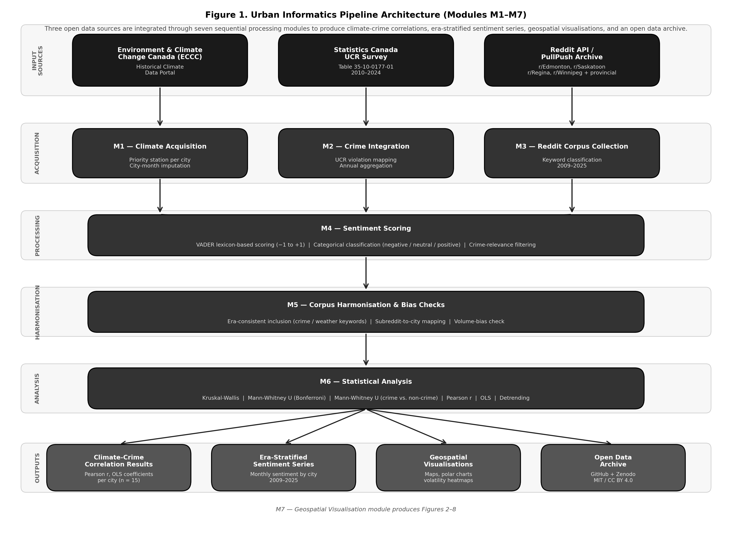

Figure 1. Architecture of the Urban Informatics pipeline (Modules M1–M7). Three open data sources are acquired through dedicated modules (M1–M3), processed through sentiment scoring (M4) and corpus harmonization (M5), subjected to statistical analysis (M6), and rendered as geospatial visualizations and reproducible outputs (M7).

3.2 Climate Data

Daily climate observations were obtained from Environment and Climate Change Canada's Historical Climate Data portal. For each city, a priority-ordered list of stations was queried for the full study period (2010–2025), with the first station returning data for a month used for that month; in practice each city's series comes from a single station (Edmonton Blatchford, Saskatoon RCS, Regina RCS, and Winnipeg A CS). Variables extracted include daily mean, minimum, and maximum temperature; total precipitation; relative humidity; wind speed; and derived thermal indices including heating degree days and cooling degree days (accumulated above 18°C). Variables exceeding a 70% missingness threshold (Humidex) were excluded. Remaining daily gaps were filled with the city's mean for that calendar month across all years, with linear interpolation for snow depth and wind chill in months without observations, and monthly and annual values were aggregated from the imputed daily series. Humidity coverage is uneven: Winnipeg has no humidity observations for 2010–2012 and few for 2013, so its 2010–2013 annual values are effectively climatological means, and Edmonton is missing 43% of 2014 and 25% of 2015 daily values.

3.3 Crime Data

Crime data were sourced from Statistics Canada's incident-based Uniform Crime Reporting Survey (Table 35-10-0177-01), providing standardized police-reported criminal incident counts across 314 violation categories (including aggregate totals) for all Canadian Census Metropolitan Areas. Records were filtered to founded actual incidents, mapped to three categories — violent crime, property crime, and total Criminal Code violations excluding traffic — and aggregated to annual city-level counts for 2010–2024.

3.4 Reddit Sentiment Data

Reddit posts were collected from seven subreddits — r/Edmonton, r/Saskatoon, r/Regina, r/Winnipeg, r/alberta, r/saskatchewan, and r/manitoba — covering 2009 through October 2025. Era 1 (2009–2013) posts were retrieved by keyword search of the PullPush archive (a community successor to Pushshift) and restricted to the seven study subreddits; 2014–2025 posts were collected through the Reddit API. Provincial subreddits were pooled with one city each (r/alberta with Edmonton, r/saskatchewan with Saskatoon, and r/manitoba with Winnipeg), so Regina's sample comes from r/Regina alone; r/alberta also covers Calgary and other Alberta communities. Posts were classified as crime-relevant using a rule-based keyword filter encompassing four thematic categories: violent crime, property crime, policing and justice, and safety and disorder language. Every era retains only posts matching the crime or weather keyword sets; the 2020–2021 collector also retained pandemic-keyword posts (57% of its raw corpus), which are excluded from all analyses so that the five eras share one inclusion rule. Non-crime posts are therefore weather-related posts. Sentiment was scored using VADER (Hutto and Gilbert, 2014), a lexicon-based model producing compound scores from −1 to +1 and categorical classifications (negative: ≤ −0.05; positive: ≥ +0.05; neutral: otherwise). All five eras are scored with VADER on the same cleaned text field.

3.5 Corpus Harmonization and Statistical Analysis

Module M5 harmonizes the corpus across eras and cities: it applies the common crime-or-weather inclusion rule and the subreddit-to-city mapping, and checks for volume bias. All statistical tests use raw post-level VADER compound scores; no per-user or seasonal normalization is applied. The volume-bias check found that annual post volume is positively associated with crime discussion share in every city (annual post counts vs. crime-relevant share, 2014–2025: r = +0.25 to +0.59), significantly only in Winnipeg (p = 0.042), so crime-share comparisons between years with very different collection volumes should be read cautiously. Statistical analysis employed Kruskal-Wallis tests for inter-city polarity comparison, Mann-Whitney U pairwise tests with Bonferroni correction, chi-square tests for categorical sentiment composition, Mann-Whitney U tests for crime versus non-crime sentiment divergence, Pearson correlations for bivariate climate-crime associations (n = 15 annual observations, 2010–2024), OLS regression for multivariate modelling with z-scored predictors, and detrended and first-difference correlations as a trend-robustness check.

4. Era-Stratification Framework

A central methodological contribution of this study is the demonstration that Reddit-derived sentiment cannot be treated as a temporally uniform perception proxy. The structural properties of online discourse — posting volume, platform membership, moderation norms, and thematic focus — changed substantially across the 2009–2025 study period, and these structural changes alter the conditions under which sentiment measurements are analytically interpretable. The pipeline therefore stratifies the study period into five analytically distinct eras.

Table 1. Tests Performed and Rationale
# | Test | Research Question Addressed | Data Used | Applied To | Justification for Choice
1 | Kruskal-Wallis H test | Do sentiment polarity distributions differ significantly across the four cities within each era? | Post-level sentiment_compound scores (Eras 2–5) | All four cities simultaneously, per era | Non-parametric equivalent of one-way ANOVA. Chosen because sentiment polarity is continuous but non-normally distributed. Tests the full distribution shape, not just means.
2 | Mann-Whitney U (Bonferroni-corrected) | Which specific city pairs drive the Kruskal-Wallis result? | Post-level sentiment_compound scores (Eras 2–5) | All six pairwise city combinations per era (6 tests × 4 eras = 24 comparisons) | Pairwise follow-up to a significant KW result. Bonferroni correction (multiplier = 6) applied to control family-wise error rate across simultaneous comparisons.
3 | Chi-square test of independence | Do cities differ in the proportional mix of negative, neutral, and positive posts — not just in polarity intensity? | Categorical sentiment_category labels (negative / neutral / positive) | 4 cities × 3 categories contingency table per era | Complements Test 1 by examining categorical composition rather than continuous polarity. Cities may share similar means but differ markedly in their negative/neutral/positive proportions.
4 | Mann-Whitney U test (crime vs. non-crime) | Is crime-relevant sentiment significantly more negative than non-crime sentiment within each city — confirming crime discourse as an analytically independent perception signal? | All crime and non-crime (weather) post sentiment_compound scores per city per era | Each city individually, per era (16 tests total) | Crime and non-crime posts are independent samples, so a two-sample rank test is applied to all posts. A significant result validates crime sentiment as a distinct construct rather than a reflection of general subreddit negativity. Loss of significance flags analytical breakdown of the perception proxy.
5a | Pearson correlation | Are annual climate variables (humidity, CDD, temperature) associated with annual violent crime counts at the city level? | Annual climate CSV joined to annual UCR crime counts (n=15 per city, 2010–2024) | Each city-variable pair independently (12 bivariate tests) | Standard bivariate correlation for continuous annual series. Three variables retained on theoretical grounds after screening (Section 5.2). No multiple-comparison correction; results are exploratory.
5b | OLS regression (z-scored predictors) | What is the combined explanatory power of temperature, humidity, and CDD for annual violent crime, and which predictor dominates within each city? | Annual climate + crime data. All predictors z-scored (mean=0, SD=1) to enable direct coefficient comparison across variables in different units | Each city separately (n=15). Durbin-Watson statistic reported to flag serial autocorrelation in residuals | Multivariate extension of Test 5a. Z-scoring allows β coefficients to be compared directly regardless of measurement units. Durbin-Watson reported because annual crime series exhibit known positive autocorrelation, which underestimates standard errors.
5c | Trend robustness (detrended and first-difference correlations) | Do the climate-crime correlations survive removal of shared time trends? | Annual climate + crime data, with a linear year trend removed from both series, or year-to-year changes | Each city-variable pair (12 detrended and 12 first-difference correlations) | Series that both trend over time correlate whether or not they are causally linked. Detrended (partial on year, df = 12) and first-difference (n = 14) correlations test whether years that deviate from trend co-vary.

Table 2. Era-stratification framework: defining structural conditions, crime-sentiment divergence significance, volatility regime, and analytical role for each of the five eras (2009–2025).
Era | Period | Defining Condition | Crime-Sentiment Divergence | Volatility | Analytical Role
1 | 2009–2013 | Sparse, episodic posting (14–136 posts per city; 1–4 posts per month). Too thin for stable estimates. | Not tested | High (SD 0.52–0.78), driven by 1–4 posts per month | Descriptive reference only
2 | 2014–2019 | Rapid growth. Crime sentiment separates structurally from weather discourse. Negative crime posts 55–73%. | Significant all cities (p < 0.01) | High (SD 0.31–0.52), largely reflecting 2–5 posts per month | First era suitable for climate-perception modelling
3 | 2020–2021 | COVID-19 disruption. Cities converge: no inter-city test significant. Crime share 38–46%, in line with other eras. | Significant in Edmonton and Saskatoon (p < 0.001); non-significant in Regina and Winnipeg | Moderate (SD 0.21–0.28) | Disruption era — excluded from primary inference
4 | 2022–2023 | Post-pandemic re-stabilization. Crime share 45–55% of posts. | Significant all cities (p < 0.001) | Lowest (SD 0.10–0.17) | Transitional — partial recovery of perception signal
5 | 2024–2025 | Full structural stability. Highest overall positivity. Crime sentiment distinct in every city. Bounded volatility. | Significant all cities (p < 0.01) — most uniform gaps across cities | Moderate (SD 0.13–0.17) | Most analytically tractable era

Table 2 operationalizes the era-stratification framework that is the study’s primary methodological contribution. Each row defines one of the five analytically distinct periods identified in the 2009–2025 study window, characterized by a defining structural condition — the platform-level and societal factors that shaped the properties of Reddit discourse during that period — alongside the corresponding crime-sentiment divergence significance, sentiment volatility regime, and analytical role assigned to that era in the climate-crime-perception modelling framework. The table makes explicit a principle that is central to the study’s design: not all periods of social media data are equally suitable for inferential analysis. Era 1 is analytically sparse; Era 2 is the first period suitable for systematic modelling; Era 3 is excluded from primary inference due to pandemic disruption; and Eras 4 and 5 represent progressive recovery toward the most tractable conditions in the dataset. Reading across any single row reveals why that era occupies the role it does — the structural condition column explains the mechanism, the divergence and volatility columns provide the empirical evidence, and the analytical role column states the practical consequence for how the data from that period are treated in subsequent analyses. Because the volatility column tracks posting density almost exactly, it is best read as an indicator of data sufficiency rather than of emotional instability.

4.1 Monthly Sentiment Score Trajectory by City and Era (2009–2025)

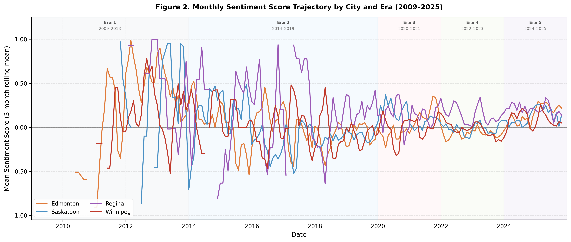Figure 2. Three-month rolling mean sentiment score by city and era (2009–2025). Shaded bands denote the five analytically distinct eras. Zero line shown for reference.

Figure 2 presents the three-month rolling mean compound sentiment score for each of the four Prairie city subreddits from January 2009 through October 2025, with the five analytically distinct eras demarcated by shaded background bands and the zero line marking the boundary between net-positive and net-negative discourse. During Era 1 (2009–2013), the lines are fragmentary and swing widely because most months contain only one to four posts; mean polarity is positive in every city — +0.419 (Edmonton), +0.248 (Saskatoon), +0.291 (Regina), and +0.183 (Winnipeg) — but rests on only 14–136 posts per city. Era 2 (2014–2019) remains highly variable, swinging repeatedly across the zero line, consistent with the monthly standard deviations of 0.310–0.516 shown in Figure 3 and its two to five posts per month; the lines then settle progressively as posting density rises through Eras 3–5. Edmonton drops to a mean of −0.058, Saskatoon to −0.089, and Winnipeg to −0.045, while Regina holds a positive mean of +0.122 — a divergence confirmed statistically by the Kruskal-Wallis result of H = 15.534 (p = 0.001) and the Bonferroni-corrected Mann-Whitney pairs in Table 4. The pandemic compression of Era 3 (2020–2021) is visible as a partial convergence of the four lines toward a shared moderate level, consistent with the non-significant Kruskal-Wallis result (H = 3.016, p = 0.389) and mean polarity values ranging only from +0.037 to +0.143 — about half the inter-city spread of Eras 2 and 4. Era 4 (2022–2023) shows re-divergence as cities process distinct post-pandemic trajectories, producing the strongest Kruskal-Wallis result in the study (H = 32.237, p < 0.001) and the largest Bonferroni-corrected pairwise gaps — Edmonton–Regina and Regina–Winnipeg both achieving p < 0.001 after correction. By Era 5 (2024–2025), the figure shows all four lines elevated above zero and converging toward a shared high-positivity baseline — mean polarity values of +0.194 (Edmonton), +0.143 (Saskatoon), +0.213 (Regina), and +0.113 (Winnipeg) — while Regina's purple line and Winnipeg's red line show the clearest directional divergence, with Edmonton trending modestly upward and Winnipeg trending downward, consistent with their contrasting post-2022 crime trajectories. From Era 2 onward, Regina's line sits consistently above the others, never sustaining the prolonged negative periods observed in Edmonton and Winnipeg during Eras 2 and 4 — a visual representation of the persistent spatial anomaly confirmed by all three Bonferroni-corrected pairwise comparisons involving Regina in Eras 2 and 4.

4.2 Sentiment Volatility (Standard Deviation of Monthly Sentiment) by City and Era

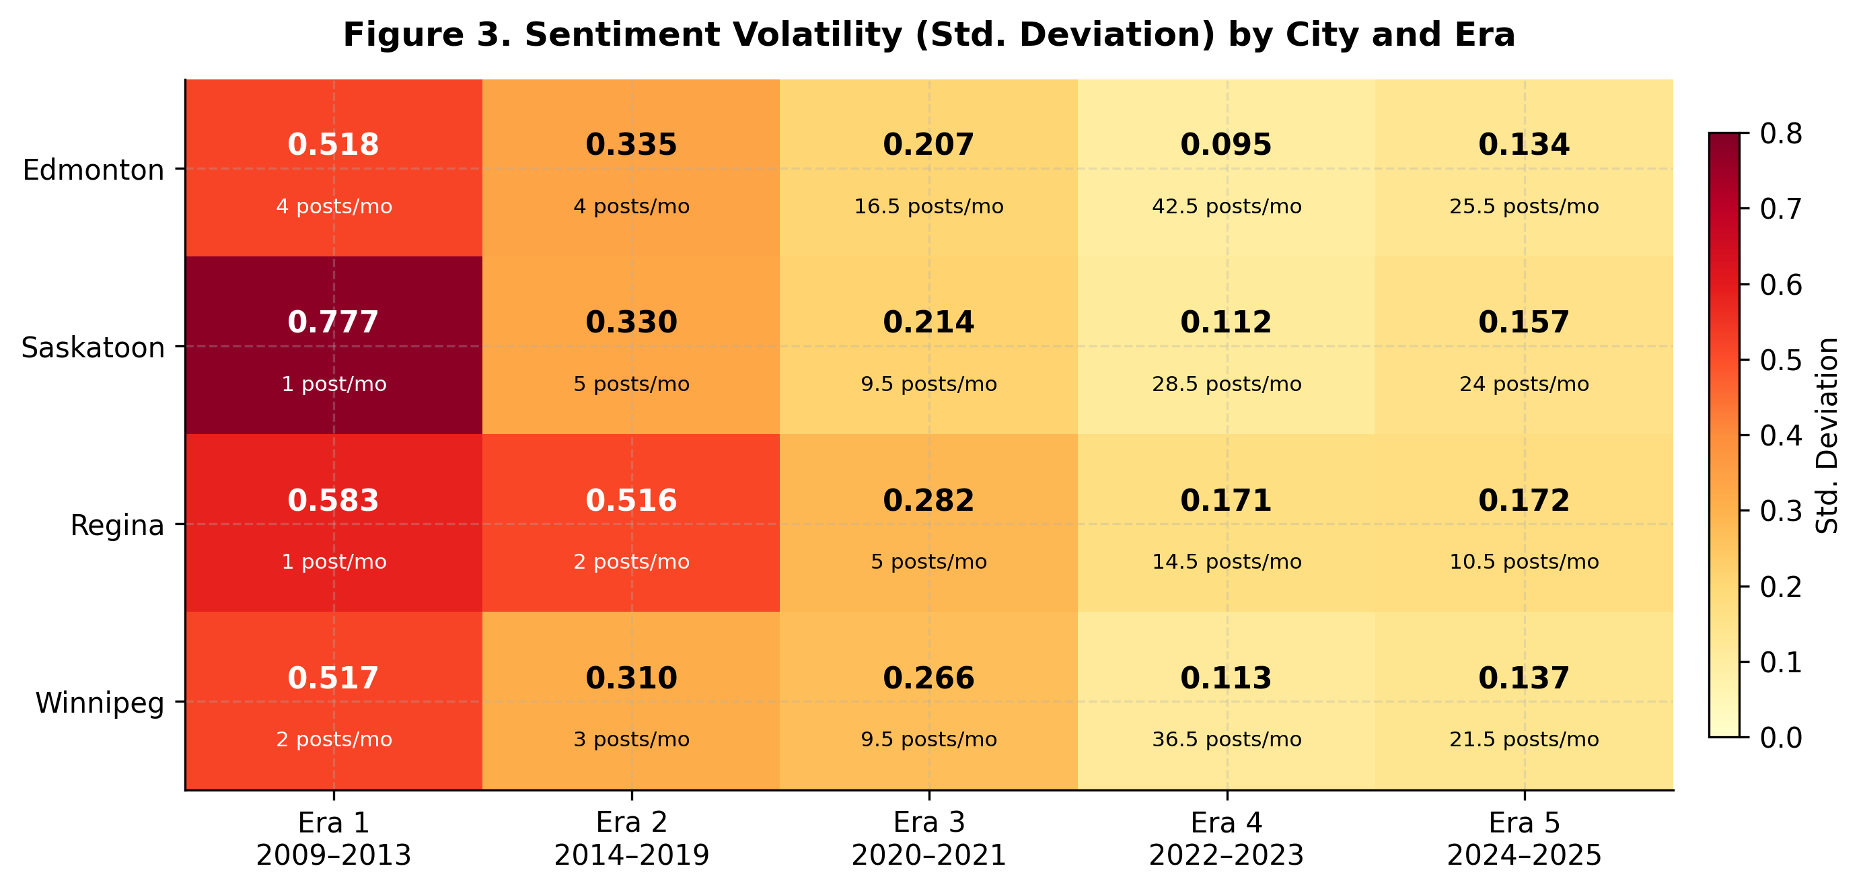

Figure 3. Sentiment volatility heat-map: monthly standard deviation by city (rows) and era (columns). Darker cells indicate higher volatility. Cell labels give the standard deviation and the median number of posts per month; volatility falls as posting density rises.

Figure 3 condenses the volatility dimension of Figure 2 into a single 4×5 color-coded grid, where each cell reports the standard deviation of monthly sentiment scores for one city-era combination. Darker cells indicate higher volatility; lighter cells indicate more stable discourse. The grid also reports the median number of posts per month in each cell, and this is the key to reading it: the standard deviation of a monthly mean shrinks as the number of posts behind it grows, so cells built from sparse months are mechanically more volatile. The darkest cells are in Era 1 (0.517–0.777; one to four posts per month) and Era 2 (0.310–0.516; two to five posts per month), and Regina — the city with the fewest posts — records the highest value in every era from Era 2 onward (0.516, 0.282, 0.171, and 0.172). Volatility then falls as posting density rises: Era 3 values range from 0.207 to 0.282 (5–16.5 posts per month), Era 4 from 0.095 to 0.171 (14.5–42.5), and Era 5 from 0.134 to 0.172 (10.5–25.5). The ranking of eras by volatility therefore mirrors their ranking by posting density, so the grid cannot by itself distinguish platform-driven emotional instability, or pandemic homogenization, from sampling noise. It is best read as a measure of data sufficiency: it identifies Eras 4 and 5 as the periods in which monthly sentiment estimates are stable enough to support inference, and Era 5's bounded volatility, together with its large and balanced samples, is part of what makes it the most analytically tractable era for climate-crime-perception modelling.

4.3 Era 1 (2009–2013): Baseline Establishment

Era 1 establishes the pre-growth baseline for the study. Era 1 posts were retrieved by keyword search across all of Reddit; retaining only posts from the seven study subreddits leaves 244 posts — Edmonton (n = 136), Winnipeg (n = 75), Saskatoon (n = 19), and Regina (n = 14) — spread over 10–35 observable months per city, with one to four posts in a typical month. Mean polarity is positive in every city, from +0.183 (Winnipeg) to +0.419 (Edmonton), and negative posts make up 28–41% of each city's sample; crime-specific means rest on as few as two posts (Saskatoon) and are not interpreted. With so few posts, Era 1 is not tested inferentially and is retained only as a descriptive reference point.

4.4 Era 2 (2014–2019): Structural Consolidation

Era 2 represents the first period in which sentiment data are analytically tractable. Posting volumes expanded substantially across all four cities — Edmonton (n = 380), Saskatoon (n = 429), Winnipeg (n = 248), Regina (n = 165) — and crime discourse became structurally separable from weather-related discourse. Four statistical tests were applied to characterize the nature and extent of inter-city and within-city sentiment differentiation.

Kruskal-Wallis (Test 1). A Kruskal-Wallis H test confirmed that sentiment polarity distributions differed significantly across the four cities (H = 15.534, p = 0.001). The result reflects distributional divergence rather than simple mean differences: Edmonton (μ = −0.058), Saskatoon (−0.089), and Winnipeg (−0.045) all carried negative mean polarity, while Regina (+0.122) was the sole city with a positive overall mean — a spatial contrast that persists across all subsequent eras.

Mann-Whitney U with Bonferroni Correction (Test 2). All three Bonferroni-corrected pairwise comparisons that achieved significance involved Regina: Edmonton–Regina (U = 25,708, p = 0.005), Saskatoon–Regina (U = 28,488, p = 0.001), and Regina–Winnipeg (U = 23,871, p = 0.023). The three remaining pairs — Edmonton–Saskatoon, Edmonton–Winnipeg, and Saskatoon–Winnipeg — showed no significant differences after correction, confirming that those three cities shared a broadly equivalent emotional profile while Regina occupied a structurally distinct register.

Chi-Square Test of Independence (Test 3). The chi-square test confirmed that cities differed not only in polarity intensity but in the proportional composition of negative, neutral, and positive posts (χ² = 30.700, df = 6, p < 0.001). Regina carried the highest positive proportion of any city in Era 2 (48.5%) and the lowest negative proportion (33.9%). Saskatoon recorded the highest negative proportion (44.3%), and Winnipeg the highest neutral share (32.7%), consistent with a more informational discourse style in that city during this period.

Crime vs. Non-Crime, Mann-Whitney U (Test 4). Crime-relevant posts were significantly more negative than non-crime posts in all four cities (all p < 0.001), validating crime sentiment as an analytically independent construct. Divergence gaps were substantial: Saskatoon (Δ = −0.585, U/n₁n₂ = 0.21), Winnipeg (−0.431, 0.24), Regina (−0.390, 0.34), Edmonton (−0.288, 0.33). The consistency of significant divergence across all four cities — despite their different overall sentiment profiles — confirms that crime discourse carries a systematically more negative charge regardless of the prevailing community tone.

4.5 Era 3 (2020–2021): Pandemic Disruption

The COVID-19 pandemic disrupted the structural properties of Prairie city subreddits in ways that temporarily undermined the analytical validity of sentiment as a perception proxy. The 2020–2021 collector also retained pandemic-keyword posts, which make up 57% of its raw corpus; these are excluded so that Era 3 follows the same crime-or-weather inclusion rule as the other eras. On that basis, crime-relevant posts account for 38–46% of posts, in line with Eras 2, 4, and 5, and samples are Edmonton (n = 429), Saskatoon (n = 253), Winnipeg (n = 231), and Regina (n = 134).

Kruskal-Wallis (Test 1). The Kruskal-Wallis test returned a non-significant result (H = 3.016, p = 0.389), indicating that the four cities converged to a shared polarity distribution. Mean polarity values ranged from +0.037 (Winnipeg) to +0.143 (Regina) — about half the inter-city spread of Eras 2 and 4. The inter-city differentiation established in Era 2 was not a stable structural property of Prairie subreddit communities; it was sensitive to exogenous shocks capable of homogenizing the emotional landscape. This convergence depends on pooling the provincial subreddits, however: restricted to the four city subreddits, Era 3 cities differ significantly (H = 11.840, p = 0.008), so the homogenization finding should be read as provisional.

Mann-Whitney U with Bonferroni Correction (Test 2). No pairwise comparison survived Bonferroni correction in Era 3. Regina — the persistent spatial outlier in Eras 2 and 4 — did not differ significantly from any other city after adjustment. No pair reached even nominal significance before correction (smallest raw p = 0.089, Regina–Winnipeg), confirming a collapse of spatial polarity differentiation during the pandemic period.

Chi-Square Test of Independence (Test 3). Categorical composition also converged: the chi-square test fell just short of significance (χ² = 12.393, df = 6, p = 0.054), making Era 3 the only era in which none of the three inter-city tests is significant. Regina recorded the highest neutral (26.1%) and lowest negative (27.6%) proportions in Era 3; Saskatoon (49.0%) and Regina (46.3%) showed the highest positive proportions, while Edmonton (42.4%) and Winnipeg (39.8%) recorded the lowest.

Crime vs. Non-Crime, Mann-Whitney U (Test 4). A partial collapse of crime-sentiment divergence occurred. Edmonton (p < 0.001, Δ = −0.226) and Saskatoon (p < 0.001, Δ = −0.317) retained statistically significant divergence. Regina (p = 0.111, Δ = −0.152) and Winnipeg (p = 0.268, Δ = −0.093) lost it. The compression came mainly from crime posts becoming less negative than in Era 2 (Regina +0.057, Winnipeg −0.021), narrowing their distance from weather-related posts. In Regina and Winnipeg, the compression was sufficient to eliminate the divergence that had defined Era 2, rendering crime sentiment in those cities analytically uninterpretable as an independent perception proxy during this period.

4.6 Era 4 (2022–2023): Post-Pandemic Re-Stabilisation

Era 4 saw the re-emergence of spatial differentiation, though under the structural pressure of Reddit's 2023 API pricing changes, which temporarily disrupted data continuity. Crime-relevant posts accounted for 45–55% of posts. Posting volumes were substantial: Edmonton (n = 1,054), Winnipeg (n = 900), Saskatoon (n = 714), Regina (n = 364).

Kruskal-Wallis (Test 1). Era 4 produced the strongest Kruskal-Wallis result in the study (H = 32.237, p < 0.001) — larger than Era 2 (H = 15.534) and reflecting a post-pandemic intensification of inter-city divergence beyond its pre-pandemic level. Mean polarity ranged from −0.074 (Edmonton) to +0.124 (Regina), with Saskatoon (−0.006) and Winnipeg (−0.045) in intermediate positions. The intensification reflects divergent post-pandemic city trajectories: Winnipeg experienced a documented crime severity surge entering 2022, Edmonton continued its secular crime increase, and Regina maintained its structurally positive discourse profile throughout.

Mann-Whitney U with Bonferroni Correction (Test 2). Three pairs survived Bonferroni correction, all involving Regina: Edmonton–Regina (U = 154,978, p < 0.001), Saskatoon–Regina (U = 113,559, p = 0.004), and Regina–Winnipeg (U = 190,968, p < 0.001). The Bonferroni-corrected p-values for Edmonton–Regina and Regina–Winnipeg were effectively zero, reflecting a substantially larger effect than in Era 2 and consistent with the widening gap between Regina's persistently positive discourse and the increasingly negative tone of the other three cities under post-pandemic crime pressure.

Chi-Square Test of Independence (Test 3). Compositional differences were again highly significant (χ² = 32.765, df = 6, p < 0.001). Regina retained the highest positive proportion (49.7%) and lowest negative proportion (33.5%) — values consistent with its Era 2 profile and confirming a durable compositional pattern rather than a transient effect. Edmonton (47.8%) and Winnipeg (46.8%) recorded their highest negative proportions across all eras. Neutral content collapsed to 15–18% across all cities, indicating that Era 4 discourse was more affectively polarized than any preceding era.

Crime vs. Non-Crime, Mann-Whitney U (Test 4). Crime-non-crime divergence was fully and robustly restored across all four cities: Edmonton (p < 0.001, Δ = −0.318), Saskatoon (p < 0.001, Δ = −0.376), Winnipeg (p < 0.001, Δ = −0.364), and Regina (p < 0.001, Δ = −0.243). Only Edmonton's gap exceeded its Era 2 value (−0.318 versus −0.288); the Saskatoon (−0.376 versus −0.585) and Winnipeg (−0.364 versus −0.431) gaps were restored but remained narrower than in Era 2. Regina retained the smallest gap: its non-crime posts remained strongly positive (+0.234), limiting the incremental negativity that crime-specific content could contribute.

4.7 Era 5 (2024–2025): Maturation and Regional Convergence

Era 5 represents the most analytically stable and mature period in the dataset. Overall sentiment reached its highest recorded levels across all cities: Edmonton (+0.194), Saskatoon (+0.143), Winnipeg (+0.113), and Regina (+0.213). This positivity surge was accompanied by a dramatic contraction of neutral content — from 15–33% in earlier eras to just 5.6–10.6% — producing the most affectively polarized discourse environment in the study. Crime-relevant posts accounted for 38–50% of subreddit activity, maintaining the analytical tractability established in Era 4.

Kruskal-Wallis (Test 1). The Kruskal-Wallis test remained significant (H = 8.720, p = 0.033), but the reduction in test statistic from Era 4 (H = 32.237) signals a meaningful attenuation of inter-city polarity differentiation. As all four cities converged toward a shared high-positivity baseline, the structural distinctiveness of individual city profiles diminished. This convergence reflects a region-wide shift in online community norms rather than an equalization of underlying crime conditions.

Mann-Whitney U with Bonferroni Correction (Test 2). No pairwise comparison survived Bonferroni correction in Era 5 — a notable structural shift from the consistent Regina outlier pattern of Eras 2 and 4. Regina–Winnipeg (p = 0.026) and Edmonton–Winnipeg (p = 0.018) were nominally significant before correction, but neither survives adjustment. Winnipeg retains the least positive overall mean (+0.113) and highest negative proportion (38.8%), remaining structurally distinct at the compositional level even as polarity distributions converge.

Chi-Square Test of Independence (Test 3). Categorical composition remained significantly heterogeneous (χ² = 17.095, df = 6, p = 0.009), driven primarily by Winnipeg's divergence from the other three cities. Edmonton (35.1% negative, 59.3% positive), Saskatoon (35.5%, 55.0%), and Regina (34.1%, 59.0%) show near-identical categorical profiles — the strongest compositional convergence observed across any era. Winnipeg (38.8% negative, 50.5% positive) remains measurably more negative and less positive, marking it as the sole compositional outlier in Era 5, reversing the long-running pattern in which Regina occupied that role.

Crime vs. Non-Crime, Mann-Whitney U (Test 4). Crime-non-crime divergence was significant in all four cities, with the most uniform gaps across cities in the dataset (a spread of 0.10, versus 0.30 in Era 2): Edmonton (p < 0.001, Δ = −0.270), Saskatoon (p < 0.001, Δ = −0.289), Regina (p = 0.001, Δ = −0.283), and Winnipeg (p < 0.001, Δ = −0.371). These gaps are amplified by the elevated positive baseline of non-crime discourse: crime posts did not become more negative in absolute terms — Edmonton crime mean = +0.038, Regina = +0.038 — but non-crime discourse shifted strongly upward (+0.308 in Edmonton; +0.321 in Regina), widening the relative separation. Era 5 therefore provides the most favourable analytical conditions for climate-crime-perception modelling: crime sentiment remains distinct in every city against the most positive non-crime baseline in the dataset.

Table 3. Kruskal-Wallis H test results by era. Tests whether sentiment polarity distributions differ significantly across the four cities simultaneously. *** p < 0.001; ** p < 0.01; * p < 0.05; ns = not significant.
Era | H statistic | p-value | Interpretation
Era 1  2009–2013 | Not tested | — | Too sparse for inferential testing (14–136 posts per city)
Era 2  2014–2019 | H = 15.534 | p = 0.001 ** | Significant inter-city differences. Regina is the primary spatial outlier — positive mean polarity (+0.122) against negative means in Edmonton (−0.058), Saskatoon (−0.089), and Winnipeg (−0.045)
Era 3  2020–2021 | H = 3.016 | p = 0.389 ns | Non-significant. Pandemic homogenised polarity distributions across cities. Mean polarity converged to +0.037–+0.143 — about half the inter-city spread of Eras 2 and 4
Era 4  2022–2023 | H = 32.237 | p < 0.001 *** | Strongest differentiation across all eras. Post-pandemic divergence in city trajectories — Edmonton (−0.074) and Winnipeg (−0.045) remain negative while Regina (+0.124) is the only city with a positive mean
Era 5  2024–2025 | H = 8.720 | p = 0.033 * | Significant but attenuated — all cities shifted toward high positivity baseline (range +0.113 to +0.213), reducing structural differentiation. Winnipeg retains most negative profile (38.8% negative)

Table 3 presents the test statistic H and its associated p-value, which indicate whether the four cities share a common polarity distribution or differ significantly in the shape and location of their sentiment profiles. Three findings stand out. First, the test is significant in three of the four eras — Era 2 (H = 15.534, p = 0.001), Era 4 (H = 32.237, p < 0.001), and Era 5 (H = 8.720, p = 0.033) — confirming that inter-city sentiment differentiation is the structural norm across the study period rather than an exception. Second, Era 3 is the sole non-significant result (H = 3.016, p = 0.389), and its position in the table is as informative as any significant result: the collapse of inter-city differentiation during the pandemic demonstrates that the spatial polarity differences observed in other eras were not fixed properties of the cities but were temporarily erased by an exogenous shock that homogenized online emotional expression across the region. Third, the rise and fall of the H statistic — from 15.534 in Era 2, collapsing to 3.016 in Era 3, surging to 32.237 in Era 4, then attenuating to 8.720 in Era 5 — traces the structural arc of the era-stratification framework directly: consolidation, disruption, intensified recovery, and partial convergence. The reduction from Era 4 to Era 5 in particular reflects not a weakening of city-specific conditions but a shared regional shift toward high positivity that compresses distributional differences from above, consistent with the crime–non-crime results in Table 6, which show crime-non-crime divergence remaining significant in every city in Era 5 against the most positive non-crime baseline in the dataset.

Table 4. Mann-Whitney U Results with Bonferroni Correction

Era | City A | City B | U | p (raw) | p (Bonf) | Sig / Note
Era 2 | Edmonton | Saskatoon | 83,940 | 0.461 | 1.000 | ns — similar negative profiles
 | Edmonton | Regina | 25,708 | 0.001 | 0.005 | ** — Regina significantly more positive
 | Edmonton | Winnipeg | 46,404 | 0.744 | 1.000 | ns
 | Saskatoon | Regina | 28,488 | <0.001 | 0.001 | ** — largest gap; Saskatoon most negative (−0.089) vs Regina most positive (+0.122)
 | Saskatoon | Winnipeg | 50,758 | 0.316 | 1.000 | ns
 | Regina | Winnipeg | 23,871 | 0.004 | 0.023 | * — Regina vs Winnipeg significant
Era 3 | Edmonton | Saskatoon | 53,200 | 0.667 | 1.000 | ns — pandemic convergence across all pairs
 | Edmonton | Regina | 26,547 | 0.180 | 1.000 | ns
 | Edmonton | Winnipeg | 51,100 | 0.506 | 1.000 | ns
 | Saskatoon | Regina | 16,172 | 0.456 | 1.000 | ns
 | Saskatoon | Winnipeg | 30,720 | 0.329 | 1.000 | ns
 | Regina | Winnipeg | 17,120 | 0.089 | 0.535 | ns — zero pairs survive Bonferroni in Era 3
Era 4 | Edmonton | Saskatoon | 351,113 | 0.017 | 0.100 | ns after correction
 | Edmonton | Regina | 154,978 | <0.001 | <0.001 | *** — strongest gap in study
 | Edmonton | Winnipeg | 459,904 | 0.246 | 1.000 | ns
 | Saskatoon | Regina | 113,559 | <0.001 | 0.004 | ** — Saskatoon more negative than Regina
 | Saskatoon | Winnipeg | 333,532 | 0.188 | 1.000 | ns
 | Regina | Winnipeg | 190,968 | <0.001 | <0.001 | *** — Winnipeg (−0.045) vs Regina (+0.124)
Era 5 | Edmonton | Saskatoon | 178,226 | 0.073 | 0.437 | ns — cities converging
 | Edmonton | Regina | 79,030 | 0.807 | 1.000 | ns
 | Edmonton | Winnipeg | 183,116 | 0.018 | 0.107 | ns after correction
 | Saskatoon | Regina | 66,374 | 0.090 | 0.542 | ns
 | Saskatoon | Winnipeg | 155,829 | 0.478 | 1.000 | ns
 | Regina | Winnipeg | 79,268 | 0.026 | 0.157 | ns — zero pairs survive Bonferroni in Era 5

4.8 Pairwise Sentiment Polarity Comparisons 3 Prairie Cities: Mann-Whitney U Results with Bonferroni Correction by Era

Table 4 presents the full results of the Mann-Whitney U pairwise comparisons with Bonferroni correction across all six city pairs and all four analytically tractable eras — 24 comparisons in total. The Bonferroni multiplier of six was applied to each raw p-value to control the family-wise error rate, meaning only pairs with corrected p-values below 0.05 are treated as statistically significant. Read across all four eras simultaneously, the table reveals two structural patterns that are more legible here than in any other results table in the study. The first pattern is the Regina consistency effect. In every era where Bonferroni-significant pairs exist — Eras 2 and 4 — all three surviving pairs involve Regina. In Era 2, Edmonton–Regina (U = 25,708, p = 0.005), Saskatoon–Regina (U = 28,488, p = 0.001), and Regina–Winnipeg (U = 23,871, p = 0.023) all clear the correction threshold while the three non-Regina pairs — Edmonton–Saskatoon, Edmonton–Winnipeg, and Saskatoon–Winnipeg — show no significant differences after adjustment. This pattern repeats exactly in Era 4, where Edmonton–Regina (U = 154,978, p < 0.001), Saskatoon–Regina (U = 113,559, p = 0.004), and Regina–Winnipeg (U = 190,968, p < 0.001) again constitute the sole surviving pairs. The magnitude of the Era 4 effect is substantially larger than Era 2 — the Edmonton–Regina and Regina–Winnipeg corrected p-values are effectively zero, compared to 0.005 and 0.023 in Era 2 — reflecting the widening gap between Regina's persistently positive discourse profile and the increasingly negative tone of the other three cities as post-pandemic crime pressures mounted. The second pattern is the dual convergence in Eras 3 and 5. Neither era produces a single Bonferroni-significant pair, but for structurally opposite reasons. In Era 3 (zero surviving pairs), the convergence was forced by pandemic disruption compressing polarity distributions toward a shared moderate level — no pair reached even nominal significance (smallest raw p = 0.089, Regina–Winnipeg). In Era 5 (also zero surviving pairs), the convergence reflects a voluntary regional shift toward high positivity: all four cities moved upward together, reducing the distributional distance between them not through compression from below but through elevation from above. Pre-correction p-values for Regina–Winnipeg (0.026) and Edmonton–Winnipeg (0.018) in Era 5 suggest residual separation at the margins, with Winnipeg remaining the least positive city, but neither achieves the corrected threshold. Together these two eras illustrate that the absence of significant pairwise differences can reflect fundamentally different structural conditions — analytical breakdown in Era 3 versus analytical maturation in Era 5 — which is why the Kruskal-Wallis and crime-non-crime results must be read alongside this table rather than treating zero surviving pairs as equivalent across eras. The U statistics themselves carry interpretable information beyond the binary significant or non-significant classification. In a Mann-Whitney U test, U divided by the product of the two sample sizes estimates the probability that a post from the first city scores higher than a post from the second: values near 0.5 indicate substantial overlap between the two distributions — the two cities are more similar — while values further from 0.5 in either direction indicate less overlap — the cities are more distinct. Examining the non-significant pairs across eras reveals that Edmonton, Saskatoon, and Winnipeg consistently show U values close to half their sample size products (U/n₁n₂ = 0.47–0.54), indicating substantial distributional overlap. Edmonton–Winnipeg in Era 4, for example, produces U = 459,904 with a raw p-value of 0.246, and Edmonton–Saskatoon yields U = 351,113 with p = 0.017 — the latter nominally significant before correction but not surviving adjustment, and suggesting that Edmonton and Saskatoon began to diverge slightly in Era 4 as their post-pandemic crime trajectories differed. By contrast, in Eras 2 and 4 the Regina pairs produce ratios further from 0.5 (0.40–0.44 with Regina as the second city, 0.58 with Regina first) — Saskatoon–Regina in Era 2 (U = 28,488; U/n₁n₂ = 0.40) is the most separated of any significant pair across the study — reflecting the sharp distributional separation between Regina's positively skewed profile and the negatively skewed profiles of the other three cities. The table also permits a direct assessment of whether the Kruskal-Wallis significant results in Eras 2, 4, and 5 are driven by a single outlier pair or by broad distributional heterogeneity across all six combinations. In Eras 2 and 4, the answer is unambiguously a single outlier: Regina. All three significant pairs involve Regina; no non-Regina pair clears the Bonferroni threshold in either era, and the raw p-values for non-Regina pairs range from 0.316 to 0.744 in Era 2 and 0.017 to 0.246 in Era 4 — none approaching conventional significance at the corrected level. In Era 5 the answer is different: no pair clears the threshold, but the two smallest raw p-values both involve Winnipeg — Edmonton–Winnipeg (0.018) and Regina–Winnipeg (0.026) — suggesting that in Era 5 the residual differentiation has shifted from a Regina effect to a Winnipeg effect, consistent with Winnipeg retaining the highest negative proportion (38.8%) and lowest positive proportion (50.5%) of any city in that era. This shift in the identity of the distributional outlier from Regina in Eras 2 and 4 to Winnipeg in Era 5 is one of the most structurally meaningful findings in the table and aligns directly with the diverging city trajectories visible in Figure 2.

Table 5. Chi-square test of independence: categorical sentiment composition (% negative, neutral, positive) by city and era. χ² tests whether cities differ in compositional mix.
Era | City | n | χ² / p | % Negative | % Neutral | % Positive | Notable Pattern
Era 2 | Edmonton | 380 | χ²=30.700  p<0.001 *** | 42.9% | 27.1% | 30.0% | High negative; moderate neutral
 | Saskatoon | 429 |  | 44.3% | 21.4% | 34.3% | Highest negative of any city in Era 2
 | Regina | 165 |  | 33.9% | 17.6% | 48.5% | Lowest negative; highest positive — Regina outlier pattern begins
 | Winnipeg | 248 |  | 39.5% | 32.7% | 27.8% | Highest neutral; lowest positive
Era 3 | Edmonton | 429 | χ²=12.393  p=0.054 ns | 38.2% | 19.3% | 42.4% | Negativity falls from Era 2 levels
 | Saskatoon | 253 |  | 36.0% | 15.0% | 49.0% | Highest positive in Era 3
 | Regina | 134 |  | 27.6% | 26.1% | 46.3% | Lowest negative; highest neutral in Era 3 (26.1%)
 | Winnipeg | 231 |  | 38.5% | 21.6% | 39.8% | Lowest positive in Era 3
Era 4 | Edmonton | 1,054 | χ²=32.765  p<0.001 *** | 47.8% | 17.7% | 34.4% | Highest negative of all cities all eras — post-pandemic crime salience
 | Saskatoon | 714 |  | 44.1% | 15.3% | 40.6% | High negative; neutral collapses to 15%
 | Regina | 364 |  | 33.5% | 16.8% | 49.7% | Highest positive in Era 4
 | Winnipeg | 900 |  | 46.8% | 16.2% | 37.0% | Second highest negative; neutral collapses
Era 5 | Edmonton | 612 | χ²=17.095  p=0.009 ** | 35.1% | 5.6% | 59.3% | Neutral collapses to 5.6% — most polarised era; positivity surge
 | Saskatoon | 549 |  | 35.5% | 9.5% | 55.0% | Similar to Edmonton; convergence of profiles
 | Regina | 261 |  | 34.1% | 6.9% | 59.0% | Near-identical to Edmonton — strongest convergence in dataset
 | Winnipeg | 554 |  | 38.8% | 10.6% | 50.5% | Highest negative of Era 5; lowest positive — Winnipeg remains most negative city

4.9 Categorical Sentiment Composition by City and Era: Chi-Square Test Results and Negative, Neutral, and Positive Post Proportions

Table 5 presents the chi-square test of independence results alongside the categorical composition — the percentage of negative, neutral, and positive posts — for each city in each era. Where Tables 3 and 4 assessed continuous polarity distributions, the chi-square asks whether cities differ in the proportional mix of how their posts are categorized, independent of the precise polarity scores within each category. Three of the four eras return significant results — Era 2 (χ² = 30.700, df = 6, p < 0.001), Era 4 (χ² = 32.765, df = 6, p < 0.001), and Era 5 (χ² = 17.095, df = 6, p = 0.009) — while Era 3 falls just short (χ² = 12.393, df = 6, p = 0.054). The chi-square therefore agrees with the Kruskal-Wallis test: during the pandemic, cities converged in categorical composition as well as in continuous polarity. Reading down each column of the contingency section reveals patterns the test statistics alone cannot convey. Edmonton and Winnipeg consistently cluster at the higher negative end — Edmonton peaks at 47.8% negative in Era 4 and Winnipeg at 46.8% — while Regina records the lowest negative proportion in every era. The neutral column is particularly informative: Winnipeg records the highest neutral share of any city in any era (32.7% in Era 2), and Regina the highest in Era 3 (26.1%). By Era 5, neutral content collapses to just 5.6–10.6% across all cities, producing the most affectively polarized discourse environment in the dataset and explaining why the chi-square remains significant even as Bonferroni-corrected pairwise comparisons find no surviving pairs. Regina’s positive proportion column tells the most consistent story in Table 5. Regina records the highest positive proportion in Era 2 (48.5%) and Era 4 (49.7%) and the second highest in Era 5 (59.0%, behind Edmonton's 59.3%), and its negative proportion is the lowest of any city across all four eras — ranging from 27.6% in Era 3 to 34.1% in Era 5. This compositional consistency across twelve years and four structurally distinct eras confirms that Regina's distinctive sentiment profile reflects a durable local discourse architecture rather than any single period's conditions. The chi-square result is the statistical confirmation of what Table 4's Bonferroni analysis established at the distributional level: Regina is the primary driver of compositional heterogeneity in the dataset. Era 5 reveals a structural transition that the other tests do not fully capture. Edmonton (35.1% negative, 59.3% positive), Saskatoon (35.5%, 55.0%), and Regina (34.1%, 59.0%) show near-identical categorical compositions — a degree of convergence not observed between any three cities in any previous era, with a standard deviation in negative proportions across these three cities of just 0.7 percentage points compared to 5.6 in Era 2 and 7.4 in Era 4. Winnipeg (38.8% negative, 50.5% positive) is the sole compositional outlier in Era 5, and its divergence — rather than Regina's — drives the Era 5 chi-square significance, representing a structural reversal of the outlier pattern that characterized the entire preceding study period and aligning directly with Winnipeg's continuing socioeconomically driven crime surge documented in Figure 5 and Table 8.

Table 6. Crime-relevant vs. non-crime (weather) sentiment divergence by city and era: Mann-Whitney U test on all posts. U/n₁n₂ = probability that a crime post scores higher than a non-crime post (0.5 = no difference). Δ = crime mean − non-crime mean.
Era | City | U/n₁n₂ | p-value | Sig | Crime Mean | Non-Crime | Δ (Crime − Non)
Era 2 | Edmonton | 0.329 | <0.001 | *** | −0.221 | +0.068 | −0.288
 | Saskatoon | 0.209 | <0.001 | *** | −0.400 | +0.186 | −0.585
 | Regina | 0.343 | <0.001 | *** | −0.126 | +0.264 | −0.390
 | Winnipeg | 0.236 | <0.001 | *** | −0.293 | +0.138 | −0.431
Era 3 | Edmonton | 0.388 | <0.001 | *** | −0.063 | +0.164 | −0.226
 | Saskatoon | 0.361 | <0.001 | *** | −0.082 | +0.235 | −0.317
 | Regina | 0.420 | 0.111 | ns | +0.057 | +0.209 | −0.152
 | Winnipeg | 0.457 | 0.268 | ns | −0.021 | +0.072 | −0.093
Era 4 | Edmonton | 0.329 | <0.001 | *** | −0.217 | +0.101 | −0.318
 | Saskatoon | 0.312 | <0.001 | *** | −0.187 | +0.189 | −0.376
 | Regina | 0.390 | <0.001 | *** | −0.010 | +0.234 | −0.243
 | Winnipeg | 0.309 | <0.001 | *** | −0.244 | +0.120 | −0.364
Era 5 | Edmonton | 0.407 | <0.001 | *** | +0.038 | +0.308 | −0.270
 | Saskatoon | 0.383 | <0.001 | *** | −0.019 | +0.270 | −0.289
 | Regina | 0.382 | 0.001 | ** | +0.038 | +0.321 | −0.283
 | Winnipeg | 0.356 | <0.001 | *** | −0.074 | +0.297 | −0.371

5 Crime vs. Non-Crime Sentiment Divergence by City and Era: Mann-Whitney U Test Results

Table 6 presents the Mann-Whitney U test results for each city in each era, comparing the compound sentiment of crime-relevant posts against non-crime (weather-related) posts within the same city and time window. The probability-of-superiority statistic (U/n₁n₂), p-value, crime mean, non-crime mean, and polarity gap (Δ = crime mean − non-crime mean) are reported for all sixteen city-era combinations. This test is the most analytically consequential in the study because it directly validates — or invalidates — the foundational assumption underlying the era-stratification framework: that crime discourse occupies a structurally distinct emotional register from weather-related discourse in the same subreddits, rather than simply reflecting the prevailing community tone. Where that assumption holds, crime sentiment can be treated as an independent indicator of public safety perception. Where it fails, as in two of the four cities in Era 3, the sentiment data cannot support inference about crime-specific concern. The Δ column is the most informative single column in the table and should be read alongside both the significance column and the era context. In Era 2, divergence gaps range from −0.288 (Edmonton) to −0.585 (Saskatoon), all significant at p < 0.001, confirming that crime discourse was substantially and consistently more negative than general discourse in the first analytically tractable era. These gaps narrow in Era 3, mainly because crime posts became less negative: Edmonton's gap shrinks to −0.226 and Saskatoon's to −0.317 (both p < 0.001), while Regina (Δ = −0.152, p = 0.111) and Winnipeg (Δ = −0.093, p = 0.268) lose significance. The partial nature of this collapse — two cities retaining significance while two lose it — is itself a substantive finding, although it does not track crime salience: crime-relevant shares in Era 3 are similar across cities (42.9% in Edmonton, 45.5% in Saskatoon, 43.3% in Regina, and 37.7% in Winnipeg), and Regina's loss of significance partly reflects its small crime sample (58 posts). The restoration of divergence in Era 4 is complete and robust. All four cities return to significance at p < 0.001, although only Edmonton's gap exceeds its Era 2 value (−0.318 versus −0.288); Saskatoon (−0.376 versus −0.585), Regina (−0.243 versus −0.390), and Winnipeg (−0.364 versus −0.431) remain narrower. This restoration confirms that the Era 3 collapse was a temporary structural disruption rather than a permanent loss of the crime-perception signal. Era 5 then produces the most uniform divergence gaps in the dataset (a spread of 0.10 across cities, versus 0.30 in Era 2): Winnipeg leads at −0.371 (p < 0.001), followed by Saskatoon (−0.289), Regina (−0.283, p = 0.001), and Edmonton (−0.270). Crucially, these gaps are not driven by crime posts becoming more negative in absolute terms — Edmonton's crime mean in Era 5 is +0.038 and Regina's is also +0.038, both positive — but by the non-crime baseline shifting dramatically upward, to +0.308 in Edmonton and +0.321 in Regina. Crime sentiment therefore stands out with greater clarity in Era 5 precisely because the emotional background against which it is measured has become substantially more positive, making Era 5 the most analytically favorable period for detecting climate-crime-perception coupling in the dataset. The U/n₁n₂ column complements Δ. It estimates the probability that a randomly chosen crime post scores higher than a randomly chosen non-crime post, so 0.5 indicates no separation and lower values indicate more consistent separation. Among significant results it ranges from 0.21 (Saskatoon, Era 2) to 0.41 (Edmonton, Era 5), and it rises to 0.42 and 0.46 for Regina and Winnipeg in Era 3, where divergence is lost; reading U/n₁n₂ and Δ together therefore separates the size of the gap from its consistency across posts.

5.1 Violent Crime Trends Across Prairie Cities

Figure 5 shows violent crime intensity at each city location for 2010, 2017, and 2024. Violent crime increased in all four cities over the study period, but with markedly different magnitudes. Edmonton recorded the largest absolute increase, from 15,197 incidents in 2010 to 22,764 in 2024 (+49.8%). Winnipeg grew from 11,192 to 15,674 incidents (+40.0%). Saskatoon increased from 4,825 to 5,444 (+12.8%), and Regina from 3,527 to 3,831 (+8.6%). The spatial divergence in crime growth — concentrated in Edmonton and Winnipeg despite all four cities sharing broadly similar warming trends — motivates within-city rather than cross-city attribution of climate signals.

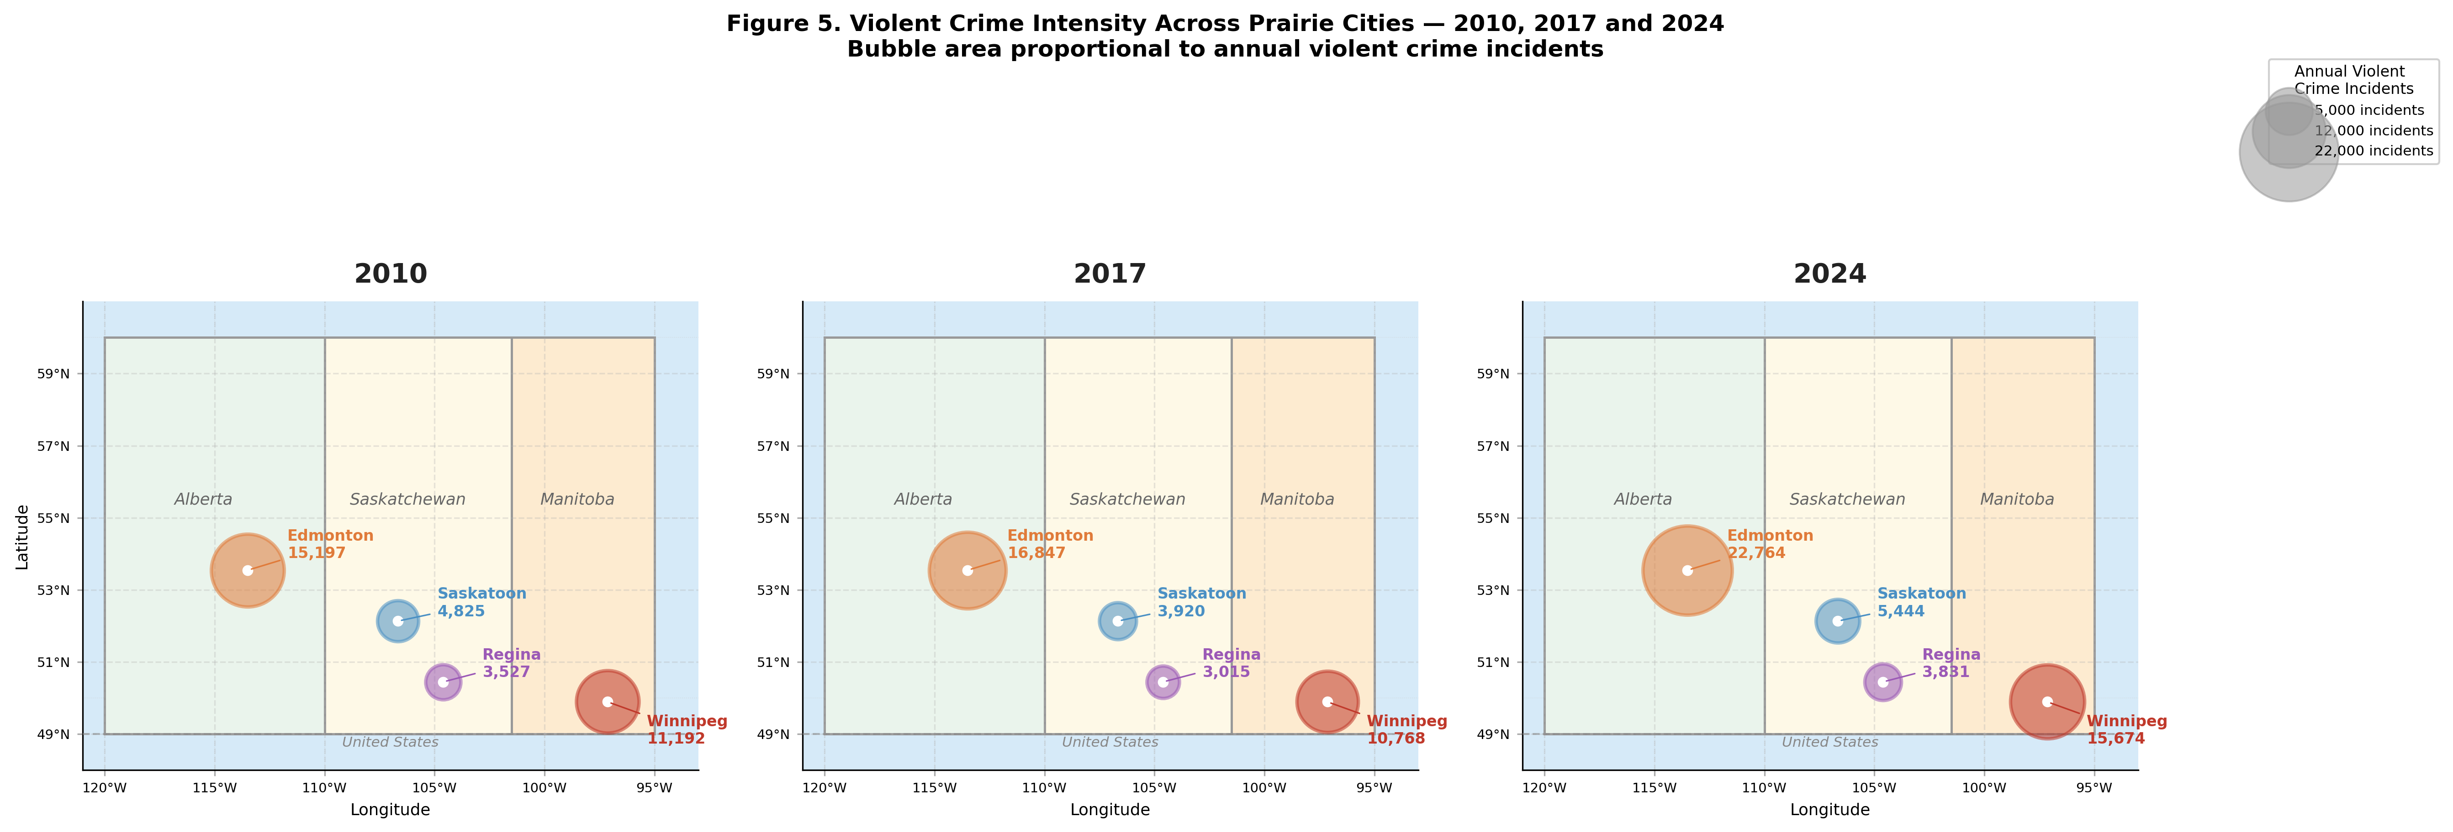

Figure 5. Violent crime intensity across Prairie cities for 2010, 2017, and 2024. Bubble area is proportional to annual violent crime incidents. Map uses Lambert-corrected projection at 52.5°N for geographic accuracy.

The year-by-year trajectories visible across the three snapshots reveal a temporal structure that aggregate growth percentages obscure. Both Edmonton and Winnipeg rose from mid-decade (by 23% and 37% respectively between 2014 and 2019) and continued rising after 2019: Edmonton averaged 15,771 violent incidents annually through 2019 then jumped to a post-2019 mean of 20,367 — a 29.1% increase in the annual average — reaching its study-period peak of 22,764 in 2024, while Winnipeg averaged 10,270 through 2019 before surging to a post-2019 mean of 13,740, peaking at 15,855 in 2023. Saskatoon and Regina show no comparable acceleration — their post-2019 increases in mean annual counts of +15.7% and +14.3% respectively remain within the range of gradual secular trends — confirming that the post-2019 crime surge is a phenomenon concentrated in the two larger cities. This bifurcation is analytically important for two reasons. First, it coincides with post-2019 climate shifts: Edmonton's annual mean humidity declined by 7.4 percentage points after 2019 while cooling degree days increased by about 82 units. Because crime and climate both move steadily over the period, however, this temporal alignment is what a shared trend would produce, and Section 5.2 shows that the climate-crime association does not survive detrending. Second, the absence of comparable acceleration in Saskatoon and Regina — despite those cities also experiencing post-2019 humidity declines of −5.5 and −4.3 percentage points respectively — confirms that climate signals alone are insufficient to explain Prairie crime trajectories and that city-specific socioeconomic contexts, absolute crime volumes, and statistical power at n = 15 all condition whether environmental stressors translate into detectable aggregate crime outcomes, which is precisely why the study employs city-specific rather than regional regression models.

Table 7. Pearson correlations between key climate variables and annual violent crime counts, by city (n = 15, 2010–2024). ** p < 0.01; † p < 0.10; ns = not significant. Temperature is the annual mean of daily maximum temperature. Detrended correlations (Test 5c) remove a linear year trend from both series.
City | Humidity  (r / p) | Cooling Degree Days  (r / p) | Mean Daily Max Temp.  (r / p) | Interpretation
Edmonton | r = −0.744  p = 0.002 ** | r = +0.707  p = 0.003 ** | r = +0.461  p = 0.084 † | Strongest raw associations, but crime, humidity and CDD all trend over 2010–2024. Detrended r = +0.27 (humidity), +0.11 (CDD), +0.15 (temperature); all p > 0.3. Not robust to the shared trend.
Winnipeg | r = +0.046  p = 0.872 ns | r = +0.217  p = 0.437 ns | r = +0.284  p = 0.304 ns | No significant climate associations. Highest average CDD (207/yr). Humidity for 2010–2013 is imputed; observed years only (2014–2024): r = +0.01. Detrended: all p > 0.25.
Saskatoon | r = −0.182  p = 0.517 ns | r = +0.182  p = 0.516 ns | r = +0.233  p = 0.403 ns | No significant associations. Smaller crime count reduces statistical power at n = 15. Detrended: all p > 0.3.
Regina | r = −0.225  p = 0.420 ns | r = +0.438  p = 0.103 ns | r = +0.217  p = 0.438 ns | Largest CDD correlation outside Edmonton, but not significant (p = 0.103). Detrended: all p > 0.28.

5.2 Pearson Correlations: Bivariate Climate-Crime Associations

Eleven annual climate variables were screened against annual violent crime counts before model entry. Eight of them reach a peak |r| ≥ 0.40 in at least one city — including wind speed (r = −0.59 in Edmonton) and maximum gust speed (r = +0.45) — so the correlation threshold alone does not narrow the set; three variables were retained on theoretical grounds as direct measures of heat and humidity stress under the General Aggression Model: mean annual relative humidity, annual cooling degree days, and the annual mean of daily maximum temperature. No correction for multiple comparisons is applied, so all correlations are exploratory. Table 7 presents the full bivariate Pearson correlation matrix for all four cities (n = 15 annual observations, 2010–2024), and Figure 4 visualizes the scatter relationships with OLS fit lines. Edmonton is the only city where climate variables achieve conventional statistical significance: mean relative humidity (r = −0.744, p = 0.002) and cooling degree days (r = +0.707, p = 0.003) carry the strongest raw associations in the dataset, and mean daily maximum temperature shows a marginal positive association (r = +0.461, p = 0.084). These associations are not robust to the time trends the series share (Test 5c). Edmonton's violent crime rises almost linearly over 2010–2024 (r = +0.92 with year), humidity falls (r = −0.86) and CDD rises (r = +0.73); with a linear trend removed from each series, the humidity and CDD correlations become r = +0.27 (p = 0.35) and r = +0.11 (p = 0.70), and year-to-year changes are uncorrelated (r = −0.08 and −0.11). Years that were drier or hotter than the trend did not have more violent crime than the trend, so the raw correlations reflect two series moving over the same period rather than evidence for a dry-heat mechanism; none of the twelve city–variable pairs is significant after detrending. Saskatoon shows no significant associations across any climate variable (all p > 0.40), consistent with the hypothesis that smaller absolute crime counts generate statistical noise that masks modest climate signals at n = 15. Winnipeg shows no significant associations despite having the highest average cooling degree days of all four cities (207 per year, versus Edmonton's 120); its humidity series is imputed for 2010–2013, and restricting to observed years (2014–2024) gives r = +0.01. Regina's largest correlation is with cooling degree days (r = +0.438, p = 0.103), which does not reach significance. The directional consistency of the temperature-crime relationship — positive in all four cities — is itself informative: the probability of four independent positive r values under the null hypothesis is approximately 6.25%, although shared upward trends in temperature and crime would produce the same pattern.

5.3 Mean Annual Relative Humidity and Cooling Degree Days vs. Annual Violent Crime Incidents by City (2010–2024, n = 15 per city)

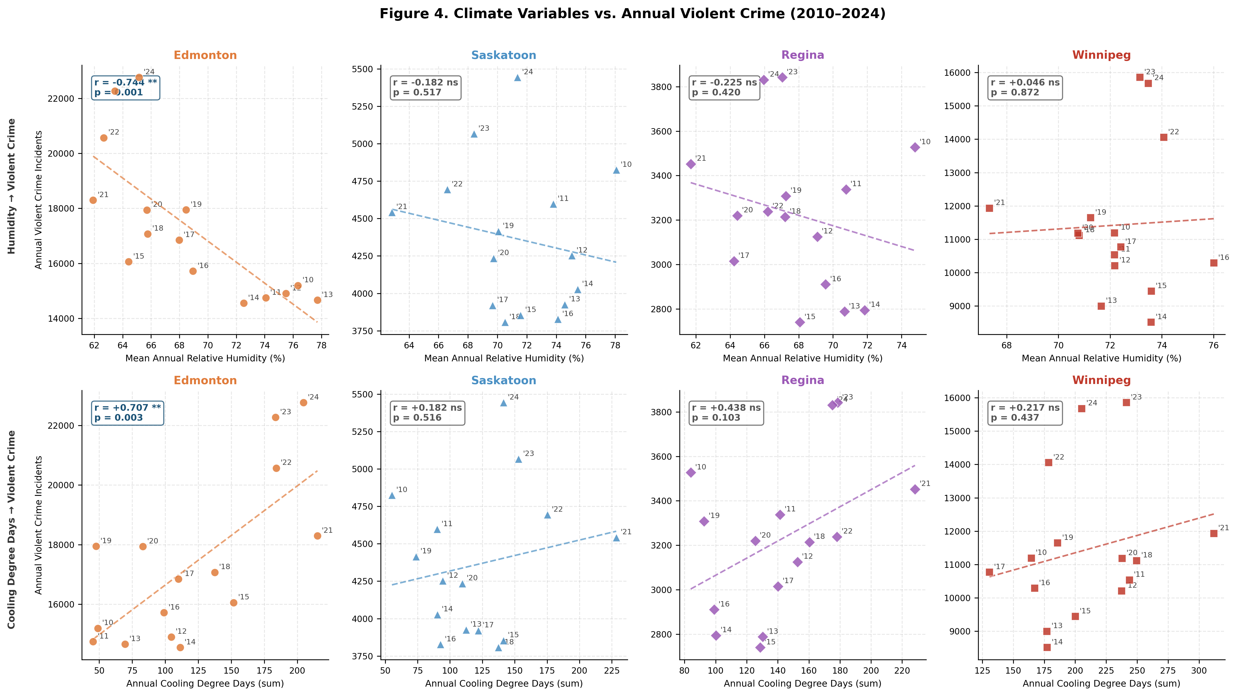

Figure 4. Climate variables vs. annual violent crime (2010–2024, n = 15 per city). Top row: mean annual relative humidity. Bottom row: annual cooling degree days. Each dot is one year, labelled with last two digits. Dashed line shows OLS fit. Pearson r and p-value annotated in each panel.

Figure 4 presents eight scatter panels arranged in a 2×4 grid, with mean annual relative humidity (top row) and annual cooling degree days (bottom row) plotted against annual violent crime for each of the four cities. Each dot represents one year of observation, labelled with its last two digits to allow the reader to trace the temporal trajectory of the climate-crime relationship, and the dashed OLS fit line makes the direction and approximate slope of each association immediately legible. The Pearson r and p-value annotated in each panel correspond to the full bivariate results reported in Table 7. The visual contrast between Edmonton's panels and the other three cities is the most immediate finding in the figure: Edmonton's humidity panel shows a clearly downward-sloping fit line with dots tightly arrayed around it — years labelled '21', '22', '23', and '24' clustering in the upper-left quadrant of high crime and low humidity, while the earlier years '10', '11', '12', and '13' sit in the lower-right of low crime and higher humidity. Because the years sort chronologically along both axes, this separation is the visual signature of the shared trend behind the r = −0.744 result rather than of year-to-year co-variation. Edmonton's CDD panel shows the complementary pattern: an upward-sloping line with recent high-CDD years coinciding with peak crime counts, consistent with r = +0.707, p = 0.003. The remaining six panels — two each for Saskatoon, Regina, and Winnipeg — are informative precisely because of their flatness. Winnipeg's CDD panel is the single most analytically important null result in the figure: despite Winnipeg having the highest average cooling degree days of any city (207 per year versus Edmonton's 120), its fit line is nearly horizontal (r = +0.217, p = 0.437). Regina's CDD panel shows the only other visible upward slope outside Edmonton (r = +0.438, p = 0.103), driven primarily by recent observations: years '21' to '24' combine high CDD with higher crime, while the three lowest-crime years ('13', '14', and '15') have lower CDD — the same time-ordered pattern seen in Edmonton, and not significant at n = 15. Saskatoon's panels show flat relationships, with dots scattered without discernible pattern and r values below 0.20 in all cases, consistent with the smallest absolute crime counts in the dataset generating proportionally more noise around any underlying climate signal.

5.4 Test 5b — OLS Regression: Multivariate Climate-Crime Model

The multivariate OLS regression model entered z-scored temperature, humidity, and cooling degree days simultaneously as predictors of annual violent crime, enabling direct comparison of coefficient magnitudes across variables measured in different units. Models were estimated separately for each city (n = 15 annual observations, 2010–2024). Results are presented alongside Durbin-Watson statistics to characterize the degree of positive serial autocorrelation in the residuals — a known property of annual crime series that causes standard errors to be underestimated and p-values to be optimistic.

Edmonton. The model achieves R² = 0.600 (Adjusted R² = 0.491), meaning that temperature, humidity, and cooling degree days together explain 60.0% of the variance in Edmonton's violent crime count — the strongest model fit in the dataset. The dominant predictors are humidity (β = −1,390 incidents per one standard deviation increase, consistent with the bivariate finding) and cooling degree days (β = +944 incidents per SD), while temperature contributes negatively once the other two variables are controlled (β = −168). This sign reversal on temperature in the multivariate model reflects the collinearity between temperature and CDD — once cumulative heat exposure is accounted for, mean daily maximum temperature is a weaker predictor. The Durbin-Watson statistic of 1.034 indicates moderate positive autocorrelation; standard errors are underestimated and the regression coefficients should be treated as exploratory. Applying Newey-West HAC-corrected standard errors is identified as a priority for future work. A linear year term alone explains 85% of the variance in Edmonton's violent crime, more than the three climate predictors combined, so the fit describes co-trending series rather than climate effects (see Test 5c).

Winnipeg. The model achieves R² = 0.134 (Adjusted R² = −0.102, DW = 0.471). The negative adjusted R² indicates that the three climate predictors explain less variance than a mean-only model after penalizing for the number of predictors — climate variables have no meaningful explanatory power over Winnipeg's crime trajectory. The DW statistic of 0.471 signals strong positive autocorrelation, further undermining inferential reliability. Coefficient signs are inconsistent with theoretical predictions (all three betas are positive, including humidity), reinforcing the conclusion that Winnipeg's crime trajectory is not explained by the climate predictors available here. The contrast with Edmonton is analytically instructive: both cities share similar warming trends, but only in Edmonton do climate and crime trends line up closely enough to produce a strong raw fit.

Saskatoon and Regina. Saskatoon's model achieves R² = 0.064 (Adjusted R² = −0.191, DW = 0.427), and Regina's achieves R² = 0.216 (Adjusted R² = 0.003, DW = 0.738). Both adjusted R² values indicate negligible or negative explanatory power after controlling for model complexity. The DW statistics for both cities (0.427 and 0.738 respectively) indicate strong positive serial autocorrelation. Regina's marginal positive CDD coefficient (β = +187) is consistent with the bivariate correlation finding but is rendered unreliable by the autocorrelation and low sample size. Taken together, the OLS results show a strong raw fit only in Edmonton, and Test 5c shows that this fit reflects shared time trends rather than year-to-year co-variation.

5.5 Era Comparison: Total Post Volume, Crime Discussion Share, and Mean Sentiment Score by City and Era (2009–2025)

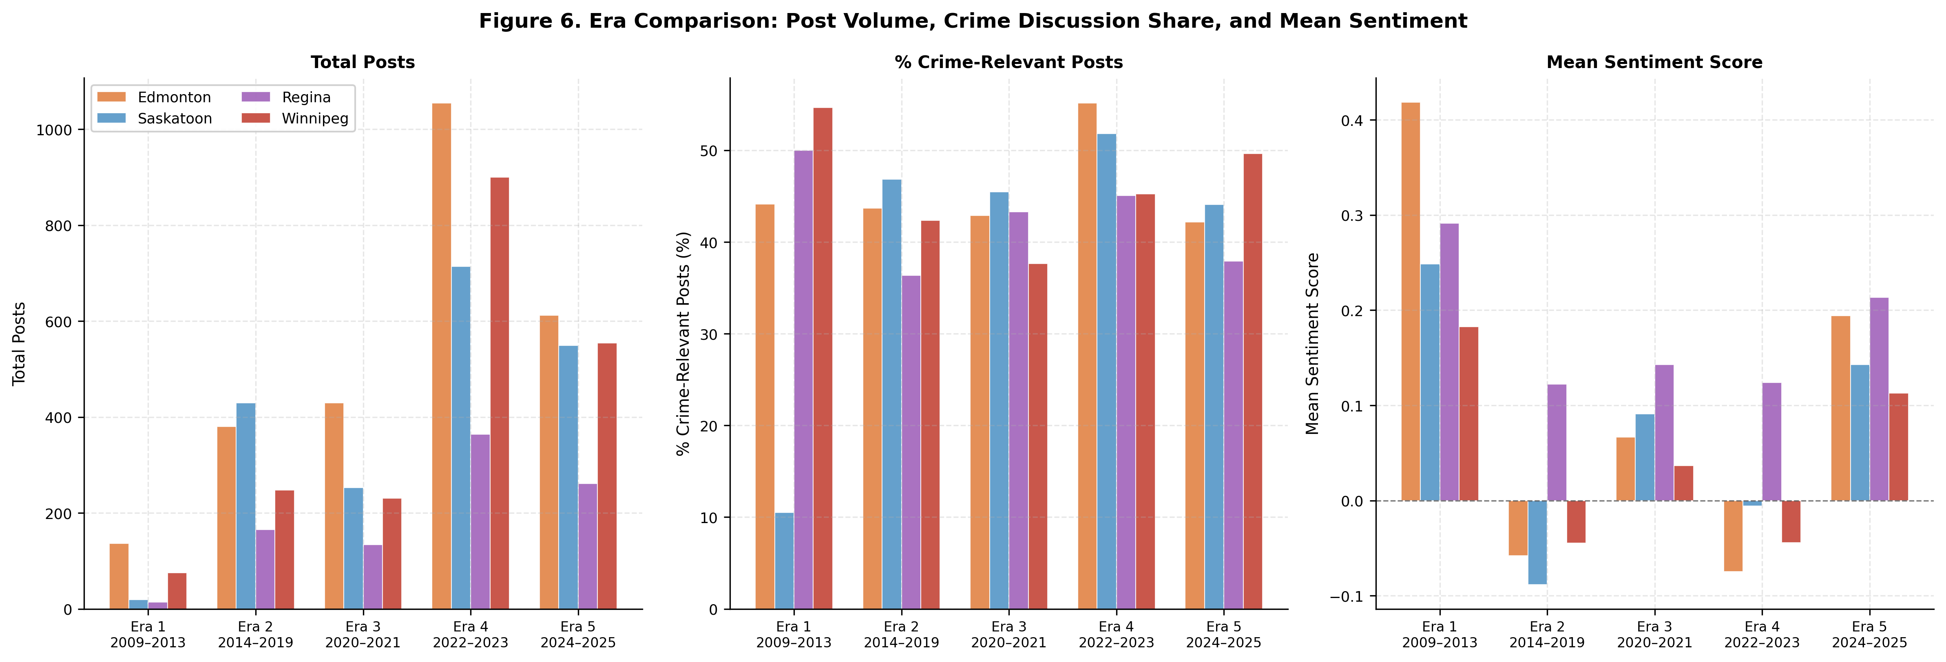

Figure 6. Era comparison: post volume (left), percentage of crime-relevant posts (center), and mean sentiment score (right) across all five eras and four cities.

Figure 6 presents three grouped bar charts arranged side by side, each showing one summary metric — total post volume (left), percentage of crime-relevant posts (center), and mean sentiment score (right) — across all five eras and all four cities. Read together, the three panels trace the structural evolution of Prairie city subreddits from sparse and undifferentiated platforms in Era 1 to high-volume, crime-attentive, and emotionally polarized communities in Era 5. The post volume panel establishes the scale context: Era 1 volumes are very small — Edmonton contributes 136 posts across 35 observable months, but Regina only 14 posts across 10 months — while Era 4 shows the largest absolute volumes. Because posts were collected through capped keyword searches, volumes reflect collection limits as well as platform activity. Edmonton generates the highest absolute volume in Eras 3 through 5 and Winnipeg the second highest in Eras 4 and 5, consistent with their larger metropolitan populations, while Saskatoon leads in Era 2. The crime discussion share panel shows that, with every era held to the same crime-or-weather inclusion rule, crime-relevant posts make up a broadly stable share of the corpus: 36–47% in Era 2, 38–46% in Era 3, 45–55% in Era 4, and 38–50% in Era 5 (Era 1 shares rest on very few posts). Era 3 shows no collapse in crime salience; the pandemic disruption captured in Table 6 is a change in the tone of crime discussion rather than in its share of posts.
The mean sentiment panel on the right is the most directly interpretable for the climate-crime-perception analysis. The panel shows that overall subreddit sentiment was positive in Era 1 (on very few posts), turned negative in Era 2 for Edmonton, Saskatoon, and Winnipeg, recovered partially during the pandemic in Era 3, dipped again in Era 4 particularly for Edmonton (−0.074) and Winnipeg (−0.045), and then surged to its highest recorded values across all cities in Era 5 — Edmonton (+0.194), Saskatoon (+0.143), Winnipeg (+0.113), and Regina (+0.213). Regina's bar is the tallest positive bar in the sentiment panel in every era except Era 1 (where Edmonton's is taller), and Regina is the only city whose bar never crosses below zero across all five eras — a visual representation of the persistent spatial anomaly confirmed by Tables 4 and 5. The Era 4 dip in Edmonton and Winnipeg sentiment, visible as their bars dropping below zero while Saskatoon and Regina remain near or above neutral, aligns in time with the post-2019 crime increase documented in Figure 5.

Table 8. OLS regression results: multivariate climate-crime model by city (n = 15, 2010–2024). All predictors z-scored. β coefficients represent incidents per one standard deviation increase. DW = Durbin-Watson statistic. Raw fits are not robust to shared time trends (see Table 7 and Test 5c).
City | n | R² | Adj. R² | DW | β Temp | β Humidity | β CDD / Interpretation
Edmonton | 15 | 0.600 | 0.491 | 1.034 | −168 | −1,390 | β CDD = +944. Strong raw fit, but crime and predictors share a time trend: a year term alone gives R² = 0.85. Humidity and CDD are dominant co-predictors. Temperature sign reverses (negative) once CDD is controlled — collinearity between temp and CDD. DW = 1.034: moderate autocorrelation.
Saskatoon | 15 | 0.064 | −0.191 | 0.427 | +95 | −50 | β CDD = +6. Negative Adjusted R² — climate adds no explanatory power. DW = 0.427: strong positive autocorrelation undermines inference.
Regina | 15 | 0.216 | 0.003 | 0.738 | +47 | +76 | β CDD = +187. Near-zero Adjusted R². Humidity sign is positive (opposite to Edmonton) — inconsistent with GAM. DW = 0.738: autocorrelation concern.
Winnipeg | 15 | 0.134 | −0.102 | 0.471 | +401 | +621 | β CDD = +703. Negative Adjusted R². All betas positive including humidity — inconsistent with GAM, climate does not explain the crime trajectory. DW = 0.471: strong autocorrelation.

5.6 Multivariate OLS Regression Results: Climate Variables vs. Annual Violent Crime by City (n = 15, 2010–2024, Z-Scored Predictors)
Table 8 presents the results of the multivariate OLS regression model estimated separately for each of the four Prairie cities, entering z-scored maximum temperature, mean relative humidity, and cooling degree days simultaneously as predictors of annual violent crime counts. Z-scoring all three predictors to a mean of zero and standard deviation of one allows the beta coefficients to be compared directly across variables measured in different units — a coefficient of −1,390 on humidity and +944 on CDD in Edmonton means that, holding the other predictors fixed, one standard deviation of lower humidity is associated with a larger difference in violent crime than one standard deviation of additional heat accumulation. The Durbin-Watson statistic is reported alongside R² and Adjusted R² because annual crime series exhibit positive serial autocorrelation, which causes OLS standard errors to be underestimated and p-values to be more favorable than a fully corrected analysis would produce. All regression findings are therefore treated as exploratory associations rather than confirmed causal effects, pending application of Newey-West heteroskedasticity and autocorrelation-consistent standard errors in future work.
Edmonton is the only city where the multivariate model achieves substantial raw explanatory power, with R² = 0.600 and Adjusted R² = 0.491 — the highest model fit in the dataset by a substantial margin. The dominant predictors are humidity (β = −1,390) and cooling degree days (β = +944), while the coefficient on mean daily maximum temperature is negative (β = −168) despite the positive bivariate correlation (r = +0.461), reflecting collinearity between temperature and CDD. Because all three predictors and violent crime trend over 2010–2024, this fit describes co-trending series: a linear year term alone explains 85% of the variance, and the detrended correlations in Table 7 show no climate-crime association once the shared trend is removed. The Durbin-Watson of 1.034 indicates moderate autocorrelation and underestimated standard errors. The contrast with the other three cities is the most analytically important finding in the table: Saskatoon (Adjusted R² = −0.191, DW = 0.427) and Winnipeg (Adjusted R² = −0.102, DW = 0.471) return negative Adjusted R² values, indicating the climate predictors add no net explanatory power after penalizing for model complexity, while Regina's near-zero Adjusted R² of 0.003 and DW of 0.738 carry no inferential weight given the severity of its autocorrelation. The Durbin-Watson values for Saskatoon and Winnipeg — both below 0.50 — indicate severe positive autocorrelation where OLS standard errors are likely underestimated by a factor of two or more. Taken together with the detrended correlations in Table 7, the regression results provide no evidence of a climate-crime association at annual resolution in any of the four cities.

6. Geospatial Patterns

Figure 7 maps the spatial distribution of Reddit negative sentiment across Prairie cities for two periods: 2014–2019 and 2022–2025. Negative sentiment increased only in Winnipeg (+3.3 percentage points); it declined slightly in Edmonton (−1.4 pp), Saskatoon (−4.5 pp), and Regina (−0.1 pp). Regina maintained the lowest negativity across both periods, consistent with its persistent positive-sentiment anomaly documented across all five eras. Co-movement between crime growth and sentiment deterioration is therefore confined to Winnipeg; Edmonton's post-2019 crime increase was not accompanied by rising negativity at this resolution. These values average Eras 4 and 5; pooling all 2022–2025 posts instead gives +0.3 pp for Edmonton and +4.2 pp for Winnipeg.

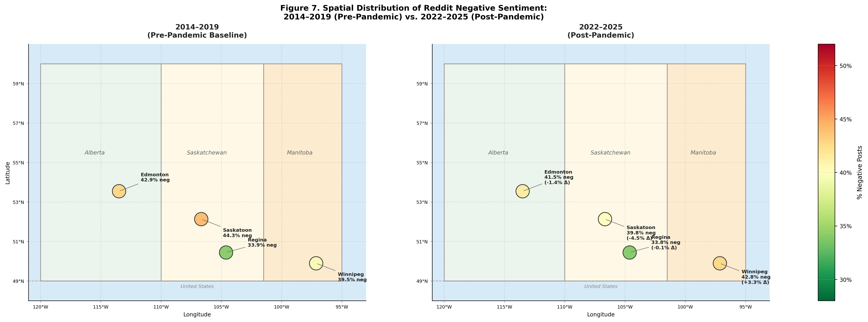

Figure 7. Spatial distribution of Reddit negative sentiment: 2014–2019 (left) and 2022–2025 (right). Bubble color encodes percentage of negative posts. Change in negativity (Δ) annotated for the post-pandemic panel.

Figure 8 shows weak and city-specific seasonal structure in sentiment: mean polarity is highest in winter in Saskatoon (+0.049) and Winnipeg (+0.085), and in spring in Edmonton (+0.035) and Regina (+0.187). Winnipeg records net-negative mean polarity in two seasons (autumn: −0.043; spring: −0.012) and Saskatoon in one (summer: −0.011). Seasonal variation is small in Edmonton, Regina, and Saskatoon (seasonal ranges of 0.03–0.06) and largest in Winnipeg (0.13), so seasonal climate variability does not meaningfully modulate Reddit discourse tone in most Prairie cities, and the pattern does not follow city size.

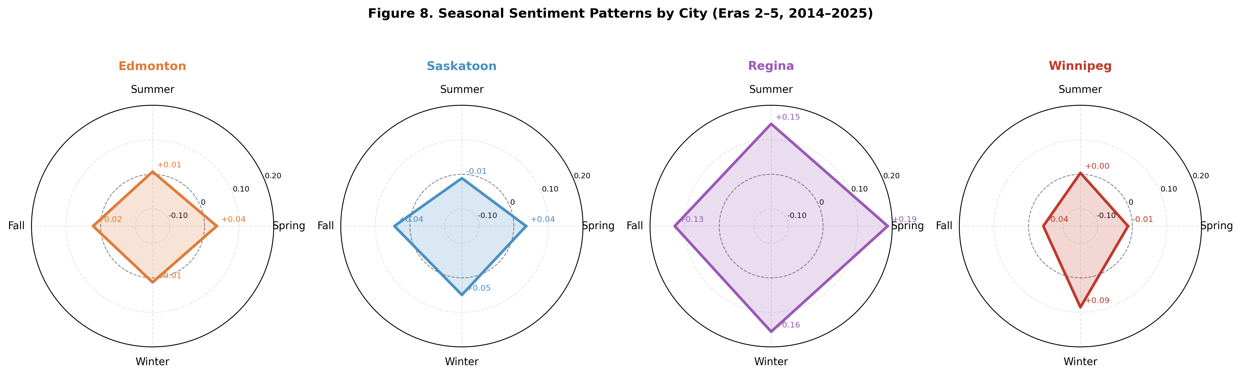

Figure 8. Polar seasonal sentiment charts by city (Eras 2–5, 2014–2025). Four compass points represent Spring, Summer, Fall, and Winter. Radial scale shows mean compound sentiment score.

7. Discussion

7.1 The Era-Stratification Framework as a Transferable Methodological Contribution

The most broadly transferable contribution of this study is the demonstration that social media sentiment cannot be treated as a temporally uniform urban perception proxy. This is not a philosophical claim about the nature of online discourse; it is an empirical finding supported by a battery of four statistical tests applied across four cities and four eras. The Kruskal-Wallis H test quantifies the extent to which inter-city polarity differentiation changes across eras — from H = 15.534 in Era 2, collapsing to H = 3.016 (ns) in Era 3, surging to H = 32.237 in Era 4, and attenuating to H = 8.720 in Era 5. The crime–non-crime Mann-Whitney U test, applied within cities, directly operationalizes the validity condition: a significant result confirms that crime discourse occupies a structurally distinct emotional register from weather-related discourse in the same subreddits, validating crime sentiment as an independent perception signal; a non-significant result flags the period as analytically compromised. The era-stratification framework converts these diagnostic outputs into a decision rule for researchers: estimate the crime–non-crime divergence before conducting substantive inference, and exclude or flag periods where the test fails. This protocol is directly transferable to any social media monitoring application — not only urban safety, but housing satisfaction, environmental concern, public health perception, or civic engagement monitoring — regardless of platform, geography, or topic domain.

The pandemic disruption documented in Era 3 provides the most rigorous test of the framework's analytical value. The crime–non-crime test returned non-significant results for Regina (p = 0.111, Δ = −0.152) and Winnipeg (p = 0.268, Δ = −0.093) while retaining significance for Edmonton (p < 0.001, Δ = −0.226) and Saskatoon (p < 0.001, Δ = −0.317). This partial collapse pattern is analytically more informative than a uniform collapse would have been: it shows that sentiment validity can hold in some communities while failing in others under the same exogenous shock. The split does not track crime salience — crime-relevant shares in Era 3 are similar across cities (37.7–45.5%) — and Regina's loss of significance partly reflects its small crime sample, so its drivers remain open. The practical implication is that monitoring systems should not assume that sentiment validity either holds or fails uniformly across a region under exogenous shock conditions. The broader implication for social media monitoring system design is that any period of widespread social disruption — pandemic, natural disaster, acute political polarization, or economic crisis — should trigger the validity battery before any substantive inference from sentiment data is attempted.

The framework's methodological contribution extends beyond the five-era stratification applied here. The three-test validity battery — Kruskal-Wallis for inter-city distributional differences, chi-square for categorical composition heterogeneity, and a Mann-Whitney U test for within-city crime-non-crime divergence — can be standardized as a pre-analysis protocol for any study that uses social media discourse as a proxy for urban safety conditions. A researcher applying this battery to a new city dataset would have a statistically grounded basis for deciding which time periods are analytically valid before committing to any substantive findings.

7.2 Edmonton's Climate-Crime Correlations as a Trend Artefact

The Edmonton climate-crime results are the study's most instructive negative finding. Mean relative humidity (r = −0.744, p = 0.002) and cooling degree days (r = +0.707, p = 0.003) are the strongest raw climate-crime correlations in the Prairie dataset, and the multivariate OLS model reaches Adjusted R² = 0.491 with humidity (β = −1,390 incidents per standard deviation) and cooling degree days (β = +944) as dominant co-predictors. Read in isolation, these numbers resemble the dry-heat amplification pathway of the General Aggression Model, but they do not survive the trend-robustness test. Over 2010–2024, Edmonton's violent crime rises almost linearly (r = +0.92 with year), annual mean humidity falls from a 2010–2019 average of 71.2% to a 2020–2024 average of 63.8%, and cooling degree days rise; any two series with steady trends over the same fifteen years will correlate strongly whether or not one affects the other. Removing a linear trend from each series reduces the humidity and CDD correlations to r = +0.27 (p = 0.35) and r = +0.11 (p = 0.70), year-to-year changes in climate and crime are uncorrelated (r = −0.08 and −0.11), and a linear year term alone explains more of the variance in violent crime (85%) than the three climate predictors combined (60%). The year-level pattern makes the same point: the three driest years (2021: 61.9%, 2022: 62.7%, 2023: 63.4%) are among the most recent and the four wettest (2013: 77.7%, 2010: 76.3%, 2012: 75.5%, 2011: 74.1%) are among the earliest, so dry years coincide with high crime because both fall late in the series. Annual data at n = 15 therefore cannot distinguish a climate effect from any other factor that changed steadily over the period, such as population growth, policing, the opioid crisis, or post-pandemic economic conditions.

The policy implication is methodological. Projected Prairie aridification under continued warming scenarios — including summer temperature increases of 2–4°C and declining growing-season precipitation for the Alberta climate zone by 2050 (Environment and Climate Change Canada, 2025; Mapfumo et al., 2023) — makes the climate-crime question important, but annual city-level correlations are not an adequate basis for answering it: as climate and crime both continue to trend, raw correlations will grow stronger without becoming more informative. The Urban Informatics pipeline therefore reports detrended and first-difference correlations alongside every raw climate-crime correlation (Test 5c), so that coincident secular trends are flagged before they are read as climate effects. Credible estimates will require higher-frequency designs that exploit short-run weather variation (e.g., Ranson, 2014; Cohen and Gonzalez, 2024), together with controls for socioeconomic drivers of crime such as poverty rates, policing levels, opioid exposure, and demographic change; the annual update architecture and modular data streams of the pipeline make that extension straightforward.

7.3 The Regina Anomaly, Discourse Culture, and the Limits of Sentiment-Based Monitoring

Regina presents the most theoretically significant spatial result in the dataset: a persistent positive crime sentiment profile across all five eras that is structurally inconsistent with its objective crime burden. In Era 4, Regina's mean polarity (+0.124) is the only positive city mean in that era, its positive post proportion is the highest of any city in that era (49.7%), and its crime-non-crime gap is the smallest of all four cities (Δ = −0.243) despite its Crime Severity Index ranking placing it consistently among Canada's highest-crime Census Metropolitan Areas. In Era 5, Regina's crime post mean (+0.038) is identical to Edmonton's (+0.038) despite Edmonton recording a violent crime count nearly six times larger in absolute terms (22,764 versus 3,831). These numbers are not artefacts of sample size or posting volume: Regina's Mann-Whitney U comparisons with Edmonton, Saskatoon, and Winnipeg are all statistically significant after Bonferroni correction in both Eras 2 and 4, and the chi-square tests show significant compositional heterogeneity — in the balance of negative, neutral, and positive posts — in Eras 2, 4, and 5, with Regina recording the lowest negative proportion of any city in every era. The decoupling is genuine, persistent, and statistically confirmed. It is also robust to the subreddit-to-city mapping: Regina is the only city whose sample comes from its city subreddit alone, and restricting the other three cities to their own city subreddits leaves all three Regina pairs significant after Bonferroni correction in Eras 2 and 4 (Edmonton–Regina in Era 2 only narrowly, p = 0.0499).

The most theoretically compelling interpretation is that online community discourse is not a monotonic function of crime incidence but is mediated by local discourse culture, subreddit moderation norms, community identity, and the social construction of safety in ways that vary systematically and durably across cities. Regina's subreddit community — r/Regina — may reflect a civic discourse orientation more focused on community pride, local belonging, and constructive engagement than on crime grievance, even under conditions of elevated objective crime burden. This interpretation is consistent with the social capital and community resilience literature: Sampson et al.'s (1997) collective efficacy framework predicts that communities with higher social cohesion and civic identity maintain more positive collective safety narratives even under structurally elevated crime risk, and Putnam's (2000) analysis of social capital suggests that communities with stronger bridging social networks are more resistant to the narrative negativity that crime fear typically generates. The pipeline cannot determine computationally whether Regina's positive discourse reflects genuine community resilience, active subreddit moderation practices, the demographic self-selection of who chooses to participate in r/Regina, or some combination of all three. Disentangling these mechanisms would require mixed-methods follow-up research — community surveys on safety perception, interviews with subreddit moderators, and comparative demographic analysis of posting populations — that is beyond the scope of this paper but is directly enabled by the pipeline's identification of the anomaly.

The Regina anomaly carries a practical warning for the design of social media safety monitoring systems. A naive monitoring system that used raw sentiment scores to rank cities by safety concern would systematically underestimate Regina's crime burden while potentially overestimating the urgency of safety conditions in Edmonton and Winnipeg where sentiment is more negative but the discourse-crime coupling is stronger and more tractable. This is not a trivial bias: a policy-facing dashboard that ranked Prairie cities by subreddit negativity would produce a ranking directly inconsistent with objective crime severity indices for at least one of the four cities studied here, potentially directing resources and attention away from where the objective burden is highest. The Urban Informatics pipeline's multi-test validation architecture — particularly the combination of crime-non-crime divergence testing and Bonferroni-corrected Mann-Whitney pairwise comparisons — is designed precisely to surface this kind of anomaly before it is misinterpreted as a substantive safety signal. A monitoring system that cannot identify cities where the expected crime-perception coupling breaks down is not merely imprecise; it is systematically misleading for a predictable and identifiable subset of the cities it monitors. The era-stratification framework and the Regina anomaly together make the case that computational urban safety monitoring must be paired with structural validity testing before any findings are communicated to policymakers or the public.

8. Limitations

Climate-crime regression models use n = 15 annual observations per city, covering the 2010–2024 window of the Statistics Canada UCR data. At this sample size, statistical power to detect a moderate Pearson correlation (|r| = 0.50) at α = 0.05 is only about 0.48 — reaching 80% power would require about 29 annual observations — and power to detect a weak correlation (|r| = 0.30) is about 0.19. Genuine moderate climate-crime associations in Saskatoon and Regina may be present but undetectable — a type II error risk rather than a confirmed null result. More fundamentally, annual climate and crime series that both trend over the study period will correlate regardless of any causal link; the detrended and first-difference correlations (Test 5c) show that none of the climate-crime associations survives removal of the shared trend. Humidity coverage is also incomplete: Winnipeg's 2010–2013 annual humidity is effectively imputed from climatological means, and Edmonton is missing 43% of 2014 and 25% of 2015 daily values. The positive serial autocorrelation detected in all four city crime series compounds this problem: Durbin-Watson statistics range from 0.427 (Saskatoon) to 1.034 (Edmonton), with Saskatoon and Winnipeg (DW = 0.471) exhibiting severe autocorrelation where OLS standard errors may be underestimated by a factor of two or more. Future work should apply Newey-West heteroskedasticity and autocorrelation-consistent standard errors to all regression models, extend the time series as additional annual UCR observations accumulate beyond 2024, and consider monthly or quarterly crime aggregations where available to increase n while retaining the annual climate matching strategy.

VADER is a lexicon-based sentiment model validated on English social media text that performs well for short, informal posts but has documented limitations in detecting irony and sarcasm — a Prairie city resident writing “great, another car break-in” registers as positive because “great” is scored positively — and in handling community-specific vernacular or culturally embedded expressions absent from its training lexicon. VADER treats each post as a self-contained unit, ignoring conversational context: replies that are negative only in relation to a preceding post are scored independently. The binary keyword classification for crime relevance is also susceptible to false positives when crime-adjacent vocabulary appears in non-crime contexts such as discussions of crime fiction, historical events, or civic policy. The 2024–2025 collector also used a shorter keyword list (28 crime and 28 weather terms, versus 34 of each in 2014–2023), which may modestly shift crime shares between eras. Future pipeline versions should evaluate transformer-based models — specifically RoBERTa or a fine-tuned BERT variant trained on social media safety discourse — against a human-annotated validation subset, and should implement context-window scoring that incorporates the parent post when scoring reply sentiment.

Reddit users skew younger, more educated, more male, and more English-speaking than the general Prairie city population (Barthel et al., 2016). In Saskatoon and Regina, where Indigenous residents account for approximately 10–12% of the metropolitan population, the underrepresentation of Indigenous voices in English-language Reddit discourse is a meaningful gap. The harmonization steps in Module M5 do not address these representativeness concerns. Findings should be interpreted as indicators of how a specific, self-selected online community discusses crime and safety rather than as measures of general public opinion, and should be contextualized alongside survey-based perception data where available. Furthermore, Reddit’s implementation of API pricing changes in mid-2023 temporarily disrupted data collection continuity, reducing the volume and completeness of posts available for Era 4 relative to what would have been collected under the prior open-access framework. The structural characteristics of Era 4 — including the recovery of crime discussion share and the re-emergence of Bonferroni-significant inter-city differences — are therefore observed against a backdrop of data access uncertainty rather than the stable collection environment of Eras 2 and 5. The inter-city comparisons are also sensitive to how provincial subreddits are assigned: with r/alberta, r/saskatchewan, and r/manitoba dropped, Era 3 cities differ significantly (Kruskal-Wallis H = 11.840, p = 0.008) and Era 5 differences become non-significant (p = 0.096), although the Regina contrasts in Eras 2 and 4 are unchanged. The Pushshift historical archive, whose community successor PullPush supplied the Era 1 data, is no longer publicly accessible under the post-2023 API regime, meaning that replication of the pipeline for new study periods will require either the Reddit API at commercial rates, alternative archiving platforms such as the Academic Torrent Reddit dataset, or community-maintained archives. Future pipeline applications should implement continuous streaming collection rather than retrospective batch retrieval, using lightweight scheduled API calls within free-tier rate limits to build a prospective longitudinal archive not vulnerable to retrospective access restrictions. This architectural change is identified as the highest-priority infrastructure improvement for the next version of the Urban Informatics pipeline.

9. Conclusion

This paper presented Urban Informatics, an open-source Python pipeline for the integrated acquisition, processing, statistical analysis, and geospatial visualization of climate, crime, and social media sentiment data across Canadian Prairie cities. Applied to Edmonton, Saskatoon, Regina, and Winnipeg across sixteen years (2009–2025), the pipeline delivers three overarching contributions spanning methodological innovation, empirical discovery, and open science infrastructure. The first contribution is the era-stratification framework, which establishes that Reddit-derived sentiment is a conditionally rather than unconditionally reliable urban perception proxy. The framework's central finding — that the structural validity of social media sentiment as a crime perception signal depends on platform maturity, posting volume, and the absence of exogenous shocks capable of homogenizing the emotional landscape — is demonstrated empirically through a battery of four statistical tests applied across four eras and four cities. The pandemic collapse of crime-sentiment divergence in Regina (p = 0.111) and Winnipeg (p = 0.268) in Era 3, while Edmonton and Saskatoon (both p < 0.001) retained significance, provides direct statistical evidence that monitoring systems treating sentiment as a temporally stable indicator produce structurally misleading outputs during periods of widespread social disruption. The three-test validity battery — Kruskal-Wallis for inter-city distributional differences (H ranging from 3.016 in Era 3 to 32.237 in Era 4), chi-square for categorical composition (significant in Eras 2, 4, and 5; p = 0.054 in Era 3), and a Mann-Whitney U test for within-city crime-non-crime divergence (gaps ranging from −0.093 in pandemic-disrupted Winnipeg to −0.585 in Era 2 Saskatoon) — constitutes a reusable diagnostic protocol transferable to any social media monitoring application regardless of platform, geography, or substantive domain. The second contribution is a cautionary climate-crime result. Edmonton's annual violent crime correlates strongly with mean relative humidity (r = −0.744, p = 0.002) and cooling degree days (r = +0.707, p = 0.003), and a three-predictor OLS model reaches Adjusted R² = 0.491; a post-2019 drying of 7.4 percentage points coincides with a 26.8% increase in violent crime across 2019–2024 and a 49.8% increase across 2010–2024. None of these associations survives the pipeline's trend-robustness test: with linear trends removed, the humidity and CDD correlations fall to r = +0.27 and +0.11 (both p > 0.3), and no climate variable is associated with violent crime in any city. Annual city-level data at n = 15 therefore cannot support a hot-dry climate-crime mechanism, and the pipeline's detrended and first-difference outputs provide a reusable guard against reading coincident secular trends as climate effects as the record lengthens and higher-frequency crime data become available.

All pipeline code is permanently available at https://github.com/ryanocampo122/Urban-Informatics. All processed datasets are archived on Zenodo (DOI: https://doi.org/10.5281/zenodo.20161031) under CC BY 4.0. The pipeline's modular M1–M7 architecture means any data stream can be replaced or extended without modifying downstream analysis modules — a design demonstrated across four cities with distinct climate profiles, crime trajectories, discourse cultures, and subreddit community sizes. The Regina anomaly — in which Bonferroni-corrected Mann-Whitney comparisons (all three pairs involving Regina significant at p < 0.05 in Eras 2 and 4) reveal a city where the expected crime-perception coupling systematically fails — demonstrates that the pipeline's diagnostic precision can distinguish city-specific discourse mechanisms from regional noise. A monitoring infrastructure that identifies where its own outputs should not be trusted is more policy-relevant than one that produces uncritical outputs uniformly. As Prairie temperatures continue to rise, the infrastructure established here provides a reusable, documented, and openly available foundation for the research and policy work required to understand, anticipate, and respond to those consequences.

References
Anderson, C.A., 1989. Temperature and aggression: Ubiquitous effects of heat on occurrence of human violence. Psychological Bulletin, 106(1), 74–96.
Anderson, C.A., Anderson, D.C., Dorr, N., DeNeve, K., Flanagan, M., 2000. Temperature and aggression. Advances in Experimental Social Psychology, 32, 63–133.
Barthel, M., Stocking, G., Holcomb, J., Mitchell, A., 2016. Seven-in-ten Reddit users get news on the site. Pew Research Center. https://www.pewresearch.org/journalism/2016/02/25/seven-in-ten-reddit-users-get-news-on-the-site/
Cohen, L.E., Felson, M., 1979. Social change and crime rate trends: A routine activity approach. American Sociological Review, 44(4), 588–608.
Cohen, F., Gonzalez, F., 2024. Understanding the link between temperature and crime. American Economic Journal: Economic Policy, 16(2), 480–514.
Corcoran, J., Zahnow, R., 2022. Weather and crime: A systematic review of the literature. Crime Science, 11(1), 16.
Danish, M., Labib, S.M., Ricker, B., Helbich, M., 2024. A citizen science toolkit to collect human perceptions of urban environments using open street view images. Computers, Environment and Urban Systems, 116, 102207.
Environment and Climate Change Canada, 2025. Historical climate data. Government of Canada. https://climate.weather.gc.ca/
Hou, K., He, Q., Wu, J., Zhang, Y., 2023. High ambient temperatures are associated with urban crime risk in Chicago. Science of the Total Environment, 856, 158846.
Hutto, C.J., Gilbert, E., 2014. VADER: A parsimonious rule-based model for sentiment analysis of social media text. Proceedings of the 8th International Conference on Weblogs and Social Media. AAAI Press.
Ito, K., Zhu, Y., Abdelrahman, M., et al., 2025. ZenSVI: An open-source software for the integrated acquisition, processing and analysis of street view imagery towards scalable urban science. Computers, Environment and Urban Systems, 119, 102283.
Lynch, M.J., Stretesky, P.B., Long, M.A., Barrett, K.L., 2022. The climate change-temperature-crime hypothesis: Evidence from a sample of 15 large US cities, 2002 to 2015. International Journal of Offender Therapy and Comparative Criminology, 66(4), 430–450.
Mahajan, S., 2024. greenR: An open-source framework for quantifying urban greenness. Ecological Indicators, 163, 112108.
Mahajan, R., Mansotra, V., 2021. Correlating crime and social media: Using semantic sentiment analysis. International Journal of Advanced Computer Science and Applications, 12(3).
Mapfumo, E., Tarnavsky, E., Cornforth, R., Sibanda, M., 2023. Climate change trends in Canadian Prairie agricultural regions. Agricultural Systems, 204, 103543.
Pease, K., Farrell, G., 2011. Climate change and crime: An exploratory review of the potential implications. International Journal of Law, Crime and Justice, 39(4), 193–203.
Putnam, R.D., 2000. Bowling Alone: The Collapse and Revival of American Community. Simon and Schuster, New York.
Ranson, M., 2014. Crime, weather, and climate change. Journal of Environmental Economics and Management, 67(3), 274–302.
Sampson, R.J., Raudenbush, S.W., Earls, F., 1997. Neighborhoods and violent crime: A multilevel study of collective efficacy. Science, 277(5328), 918–924.
Statistics Canada, 2021. Police-reported crime statistics in Canada, 2021 (Catalogue no. 85-002-X). Government of Canada.
Statistics Canada, 2024. Uniform Crime Reporting Survey (UCR), Table 35-10-0177-01. Government of Canada.

